SUBCOURSE EDITION
SS0716 B

US ARMY SIGNAL SCHOOL

INSTALL, OPERATE, AND PERFORM
ORGANIZATIONAL MAINTENANCE ON
RADIO SETS AN/PRC-104 AND
AN/GRC-213, PART I

SINGLE CHANNEL RADIO OPERATOR
MOS31C SKILL LEVEL 1

Author: Mr. Willie Rose, ATSF-E, AV 639-5476, Commercial (405) 351-5476, FTS 744-5476

INSTALL, OPERATE, AND PERFORM ORGANIZATIONAL MAINTENANCE
ON RADIO SETS AN/PRC-104 AND AN/GRC-213, PART I

SUBCOURSE SS0716

US Army Signal School
Fort Gordon, Georgia

Four Credit Hours

GENERAL

This subcourse is designed by the US Army Field Artillery School to train the skills necessary for performing tasks related to installing, operating, and performing operator's preventive maintenance checks and services. This subcourse is presented in seven lessons, each lesson corresponding to a terminal learning objective supporting the following soldier's manual tasks.

LESSON 1: Identify the Components and State the Characteristics and Capabilities of Radio Set AN/PRC-104

TASK NO: To be assigned

TASK: Identify the components and state the characteristics and capabilities of radio set AN/PRC-104.

CONDITIONS: This task is performed when directed by your supervisor. You will be provided with the following:

1. Radio set AN/PRC-104.
2. TM 11-5820-919-12.
3. Batteries BA-5590.

STANDARDS: This task has been accomplished when performance measures 1 through 5 have been completed.

1. Major components have been identified.
2. Switches and their functions have been named.
3. Cables and connectors have been identified.
4. Characteristics have been stated.
5. Capabilities have been stated.

LESSON 2: Install and Operate Radio Set AN/PRC-104

TASK NO: To be assigned

TASK: Install and operate radio set AN/PRC-104.

i

CONDITIONS: This task is performed as required by the mission or as directed by your supervisor. You will be provided with the following:

1. Radio set AN/PRC-104.
2. TM 11-5820-919-12.
3. Batteries BA-5590 or BA-590.

STANDARDS: This task has been accomplished when performance measures 1 through 4 have been completed.

1. Batteries have been installed in CY-7875.
2. Components have been latched together.
3. Accessories and cables have been connected.
4. Operational check has been performed.

LESSON 3: Perform Operator's Preventive Maintenance Checks and Services (PMCS) on AN/PRC-104

TASK NO: To be assigned

TASK: Perform operator's preventive maintenance checks and services (PMCS) on AN/PRC-104.

CONDITIONS: This task is performed as scheduled, when the radio set is operated, or as directed by your supervisor. You will be provided with the following:

1. Installed AN/PRC-104.
2. TM 11-5820-919-12.
3. Cleaning supplies.

STANDARDS: This task has been accomplished when performance measures 1 through 4 have been completed.

1. Radio set has been cleaned.
2. All cables and connectors are clean and serviceable.
3. All accessories have been inspected.
4. Operational check has been performed.

LESSON 4: Identify Components and State the Characteristics and Capabilities of Radio Set AN/GRC-213

TASK NO: To be assigned

TASK: Identify components and state the characteristics and capabilities of radio set AN/GRC-213.

CONDITIONS: This task is performed when directed by your supervisor. You will be provided with the following:

1. Radio set AN/GRC-213.
2. TM 11-5820-923-12.

ii

STANDARDS: This task has been accomplished when performance measures 1 through 5 have been completed.

1. Major components have been identified.
2. Switches and their functions have been named.
3. Cables and connectors have been identified.
4. Technical characteristics have been stated.
5. Capabilities have been stated.

LESSON 5: Install Radio Set AN/GRC-213 in a Vehicle

TASK NO: To be assigned

TASK: Install radio set AN/GRC-213 in a vehicle.

CONDITIONS: This task is performed as required by the mission or as directed by your supervisor. You will be provided with the following:

1. Radio set AN/GRC-213.
2. TM 11-5820-923-12.
3. Vehicle with installation kit installed.

STANDARDS: This task has been accomplished when performance measures 1 through 3 have been completed.

1. Radio components have been latched together and to the mount.
2. Accessories and cables have been connected.
3. Operational check has been performed.

LESSON 6: Operate Radio Set AN/GRC-213

TASK NO: To be assigned

TASK: Operate radio set AN/GRC-213.

CONDITIONS: This task is performed as required by the mission or as directed by' your supervisor. You will be provided with the following:

1. Radio set AN/GRC-213 installed.
2. TM 11-5820-923-12.

STANDARDS: This task has been accomplished when an operational check has been performed.

LESSON 7: Perform Operator's Preventive Maintenance Checks and Services (PMCS) on AN/GRC-213

TASK NO: To be assigned

TASK: Perform operator's preventive maintenance checks and services (PMCS) on AN/GRC-213.

iii

CONDITIONS: This task is performed as scheduled, when the radio set is operated, or as directed by your supervisor. You will be provided with the following:

1. Installed radio set AN/GRC-213.
2. TM 11-5820-923-12.
3. Cleaning supplies.
4. DA Form 2404.

STANDARDS: This task has been accomplished when performance measures 1 through 5 have-been completed.

1. Radio set has been cleaned.
2. All cables and connectors are clean and serviceable.
3. All accessories have been inspected.
4. Operational check has been performed.
5. DA Form 2404 listing all uncorrected faults has been submitted.

iv

TABLE OF CONTENTS

Section Page

TITLE PAGE i

TABLE OF CONTENTS v

ADMINISTRATIVE INSTRUCTIONS vii

GRADING AND CERTIFICATION INSTRUCTIONS vii

Lesson 1: Identify the Components and State the Characteristics and
Capabilities of Radio Set AN/PRC-104

Introduction 1

Components 4

Auxiliary Equipment 7

Technical Capabilities 10

Summary 12

Lesson 2: Install and Operate Radio Set AN/PRC-104

Introduction 13

Assembling Procedures 13

Operator's Controls and Indicators 15

Preliminary Setup 19

Test Procedures 19

Operating Procedures 20

Disassembly and Transport Procedures 20

Summary 21

Lesson 3: Perform Operator's Preventive Maintenance Checks and Services

Introduction 23

Operator's Daily and Weekly PMCS 23

Corrosion Control 25

Summary 25

v
Section Page

Lesson 4: Identify the Components and State the Characteristics and
Capabilities of Radio Set AN/GRC-213

Introduction 27

Components and Characteristics 28

Technical Capabilities 31

Summary 33

Lesson 5: Install Radio Set AN/GRC-213 in a Vehicle

Introduction 35

Installation Procedures 35

Antenna Connection 38

Connectors and Functions 38

Summary 41

Lesson 6: Operate Radio Set AN/GRC-213

Introduction 43

Operator's Controls and Indicators 43

Environment 43

Initial Presets 46

Power 46

Operation of Radio Set AN/GRC-213 46

Summary 47

Lesson 7: Perform Operator's Preventive Maintenance Checks and Services on AN/GRC-213

Introduction 49

Operators Preventive Maintenance 49

Operator's Troubleshooting 50

Summary 52

EXAMINATION E-1

vi

THIS PAGE INTENTIONALLY LEFT BLANK

vii

Lesson 1
IDENTIFY THE COMPONENTS AND STATE THE CHARACTERISTICS
AND CAPABILITIES OF THE RADIO SET AN/PRC-104

OBJECTIVE

Upon completing this lesson, you will be able to identify the components and state the characteristics and capabilities of the radio set AN/PRC-104.

REFERENCES

This lesson is based on the contents of TM 11-5820-919-12 and other materials approved for US Army instruction. However, development and progress render the text continually subject to change. Therefore, base your examination answers on material presented in this lesson rather than on individual or unit experience.

1. INTRODUCTION. The radio set AN/PRC-104 is a tactical, manpack state-of-the- art, battery-powered, lightweight radio transceiver that operates in the high frequency (HF) and the upper part of the low frequency (LF) portions of the radio spectrum. The receiver/transmitter can be tuned to any frequency between 02,000.0 and 29,999.9 megahertz (MHz) in 100-hertz (Hz) increments. This makes it possible to tune up to 280,000 separate frequencies. The radio set operates in the upper sideband (USB) or lower sideband (LSB) modes for voice communications, continuous wave (CW) for morse code. In the manpack configuration, the radio set is designed to be carried and operated by one man. It weighs approximately 15.7 pounds (lbs) with all accessories (Fig 1).

a. The control panel has been engineered for ease of operation (Fig 2). This makes it possible to adjust all controls even while wearing heavy gloves. Unlike older similar radio sets, there are no front panel meters or indicator lights on the AN/PRC-104. All functions that formerly required these types of indicators (antenna tuning, battery condition, etc.) are monitored by the radio itself and communicated to the operator as special tones in the handset. This feature is particularly useful during tactical blackout operations. The superior design and innovative features of the AN/PRC-104 make it possible to maintain reliable long-range communication by using lightweight, portable equipment that can be operated by personnel with a minimum of training. Also, this radio set can be remoted by using radio set control groups AN/GRA-39 or AN/GRA-39A.

b. In this lesson, you will learn the basic components of the AN/PRC-104 and its characteristics, auxiliary equipment, and technical capabilities.

1

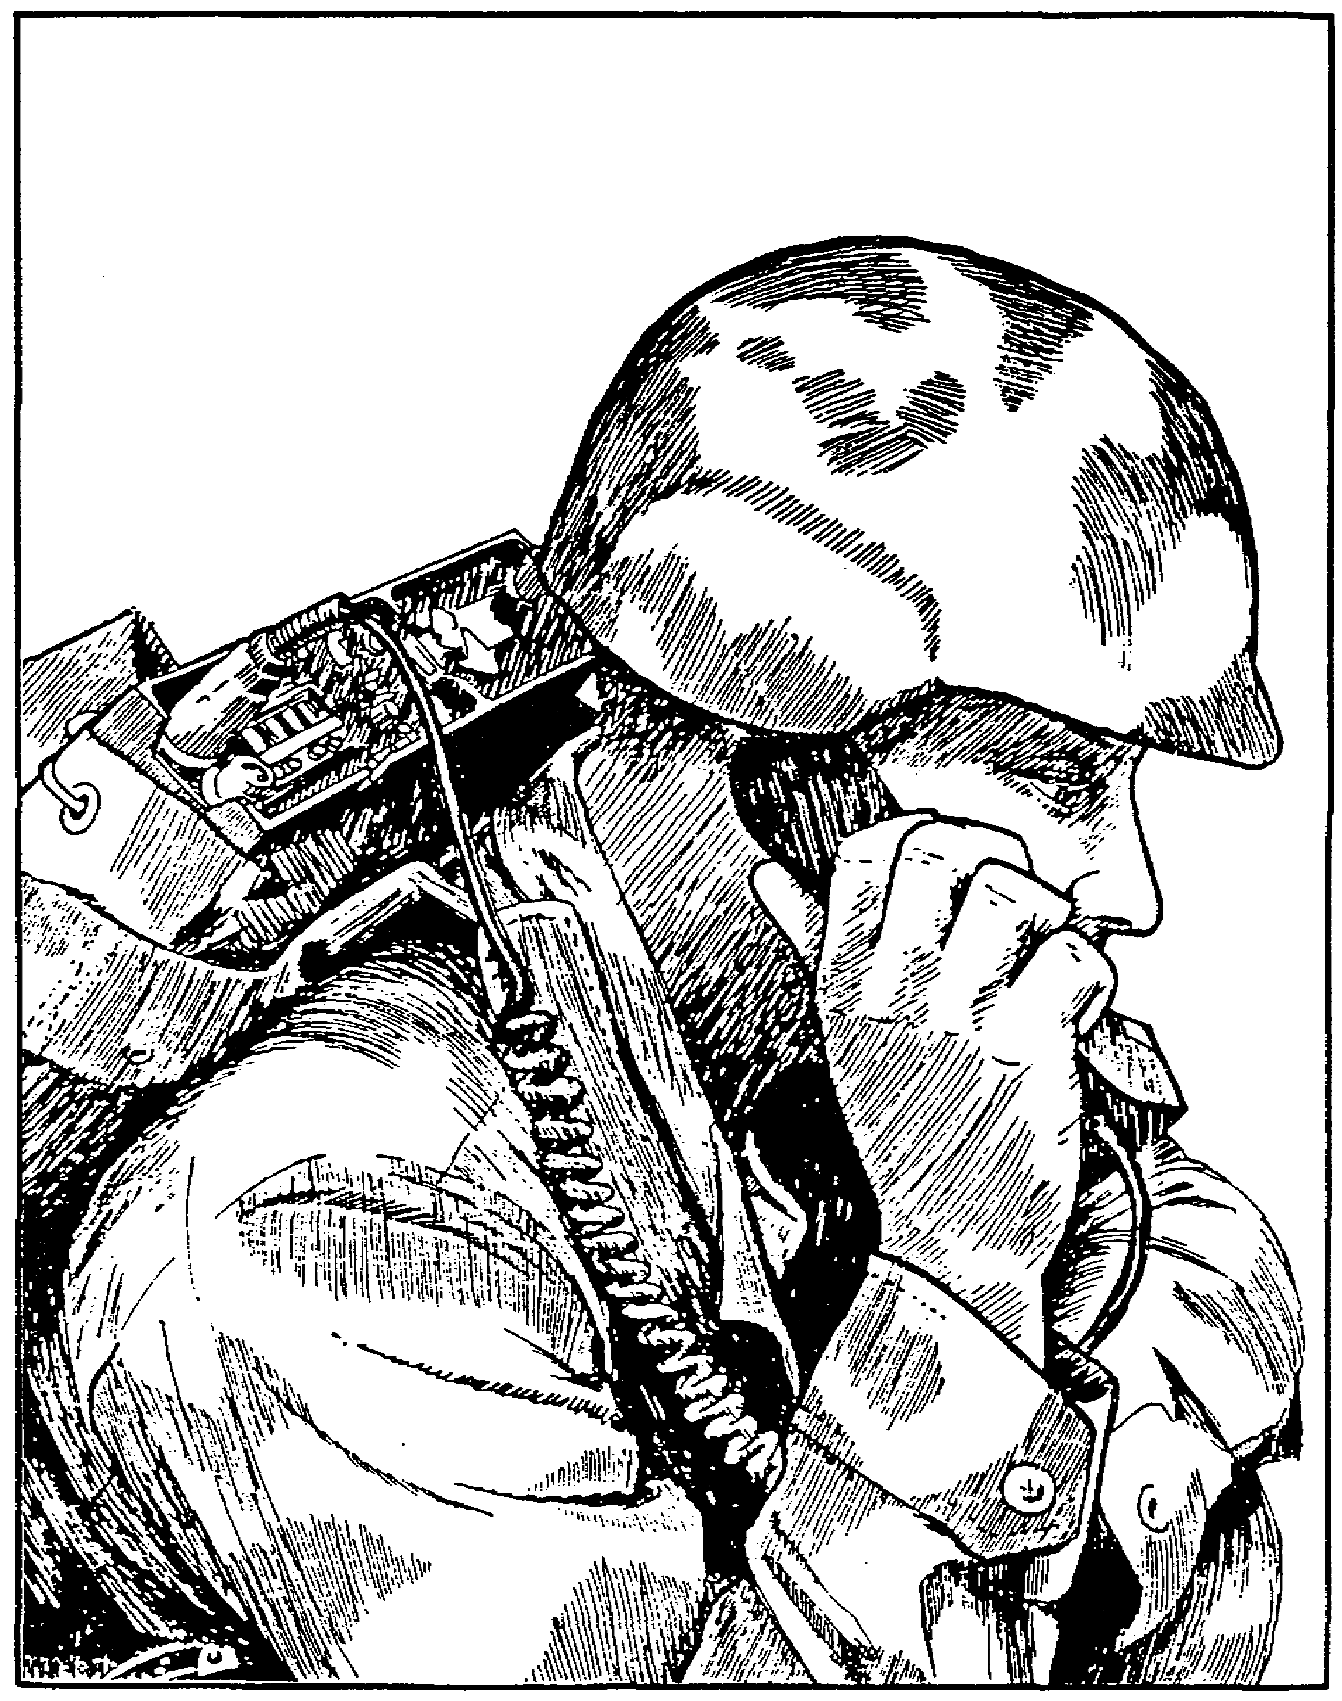

Figure 1. AN/PRC-104 in manpack operation.

2

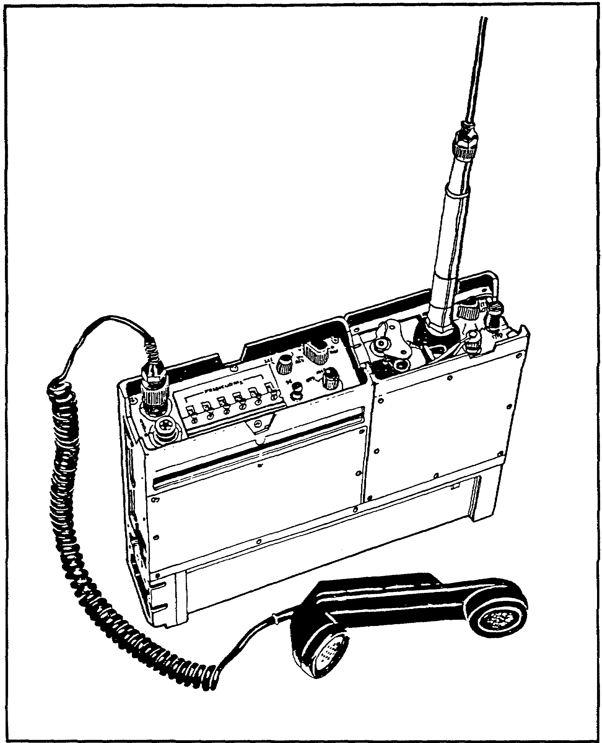

Figure 2. Radio set AN/PRC-104.

3

2. COMPONENTS. The radio set AN/PRC-104 and its components are issued in the transit case (Fig 3), which is used to store and transport the radio set when it is not in use. The major components of AN/PRC-104 are secured together by quick-disconnect latches. The electrical connections for the receiver/exciter and the amplifier are made through built-in connectors on the two components. The electrical connections for the battery pack are built-in on the amplifier/coupler and the battery pack. The major components of the radio set are:

a. Receiver-transmitter RT-1209. The RT-1209 receiver-transmitter is a miniaturized HF-single sideband transceiver that provides control of the frequency, mode selection, single sideband (SSB) transmit/receive switching, and tuning of the radio set. The receiver- transmitter can be operated in the USB or LSB voice or data modes set at any frequency from 02,000.0 to 29,999.9 MHz in increments of 100 Hz. Audio connections are provided for a handset, headset, CW key, or data input. The transmitter generates an SSB carrier, either USB or LSB, of 250 milliwatts (mW). In the receiver-transmitter, received signals are converted and demodulated to audio signals and are sent to the headset speaker. The transmitter provides frequency control and transmit/receive control by switching signals to the coupler. It is supplied with 26.5 volts (V) DC power by way of power amplifier. The receiver-transmitter (RT-1209) and the amplifier/coupler (AM-6874) are installed together.

b. Radio frequency amplifier 20 watt AM-6874/PRC 104-A (amplifier/coupler). The AM-6874/PRC 104-A is both an amplifier and a coupler. It amplifies signals from the RT-1209 from .25 watt (W) to 20 W and allows one of three possible antennas to be selected.

c. Battery case CY-7875/PRC-104 (battery pack). The CY-7875/PRC-104 battery case supplies power to the radio set (Fig 4).

4

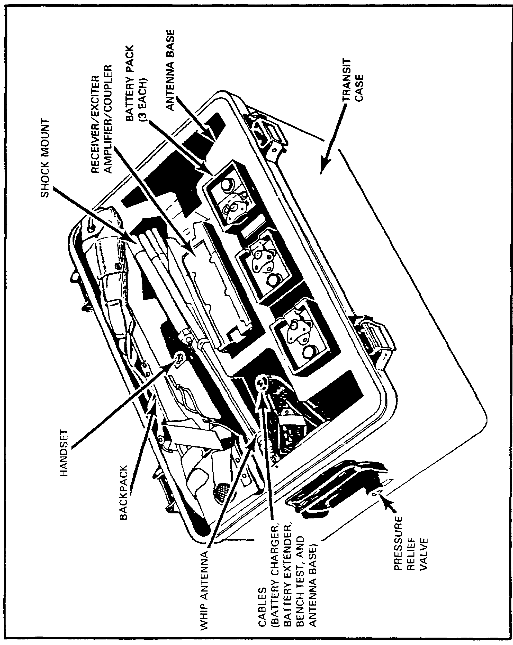

Figure 3. Transit case for radio set AN/PRC-104 and equipment supplied.

5

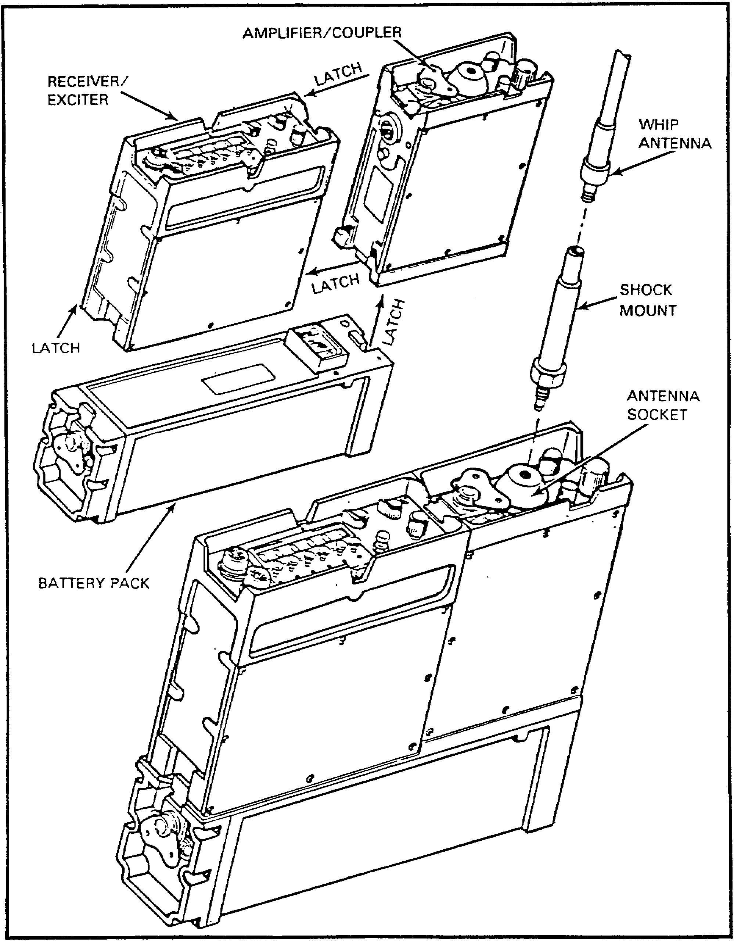

Figure 4. Radio set AN/PRC-104 installation and setup.

6

3. AUXILIARY EQUIPMENT. Now that you have learned the basic components of the radio set AN/PRC-104, you are ready to learn the auxiliary equipment of the radio set. This equipment is listed in Table 1 and pictured in Figure 5. This is all the equipment you will need for manpack operation. If desired and the tactical situation permits, you can extend the range of the AN/PRC-104 by using antenna AS-2259/GR (near-vertical incidence skywave [NVIS] antenna) or a simple half-wave dipole antenna AN/GRA-50. Neither of these antennas is supplied with the AN/PRC-104.

7

Table 1. Equipment supplied.

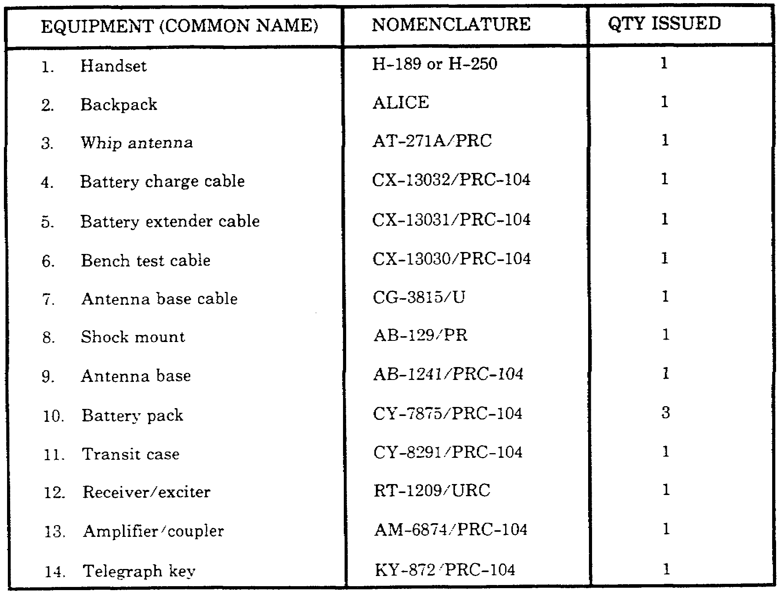

8

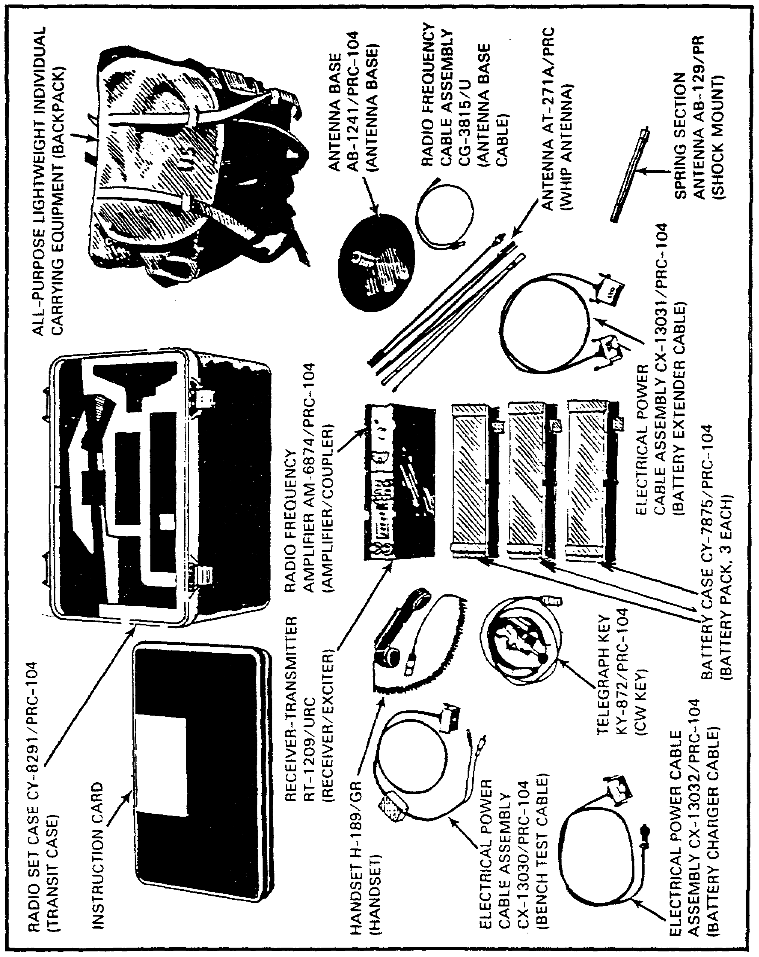

Figure 5. Components and auxiliary equipment issued with AN/PRC-104.

9

4. TECHNICAL CAPABILITIES. Now that you know the basic components and the auxiliary equipment of radio set AN/PRC-104, lets look at the technical capabilities of this radio set. It is important that you understand these capabilities so that you will know the limitations of the equipment and gain confidence with its dependability.

Table 2. Technical capabilities.

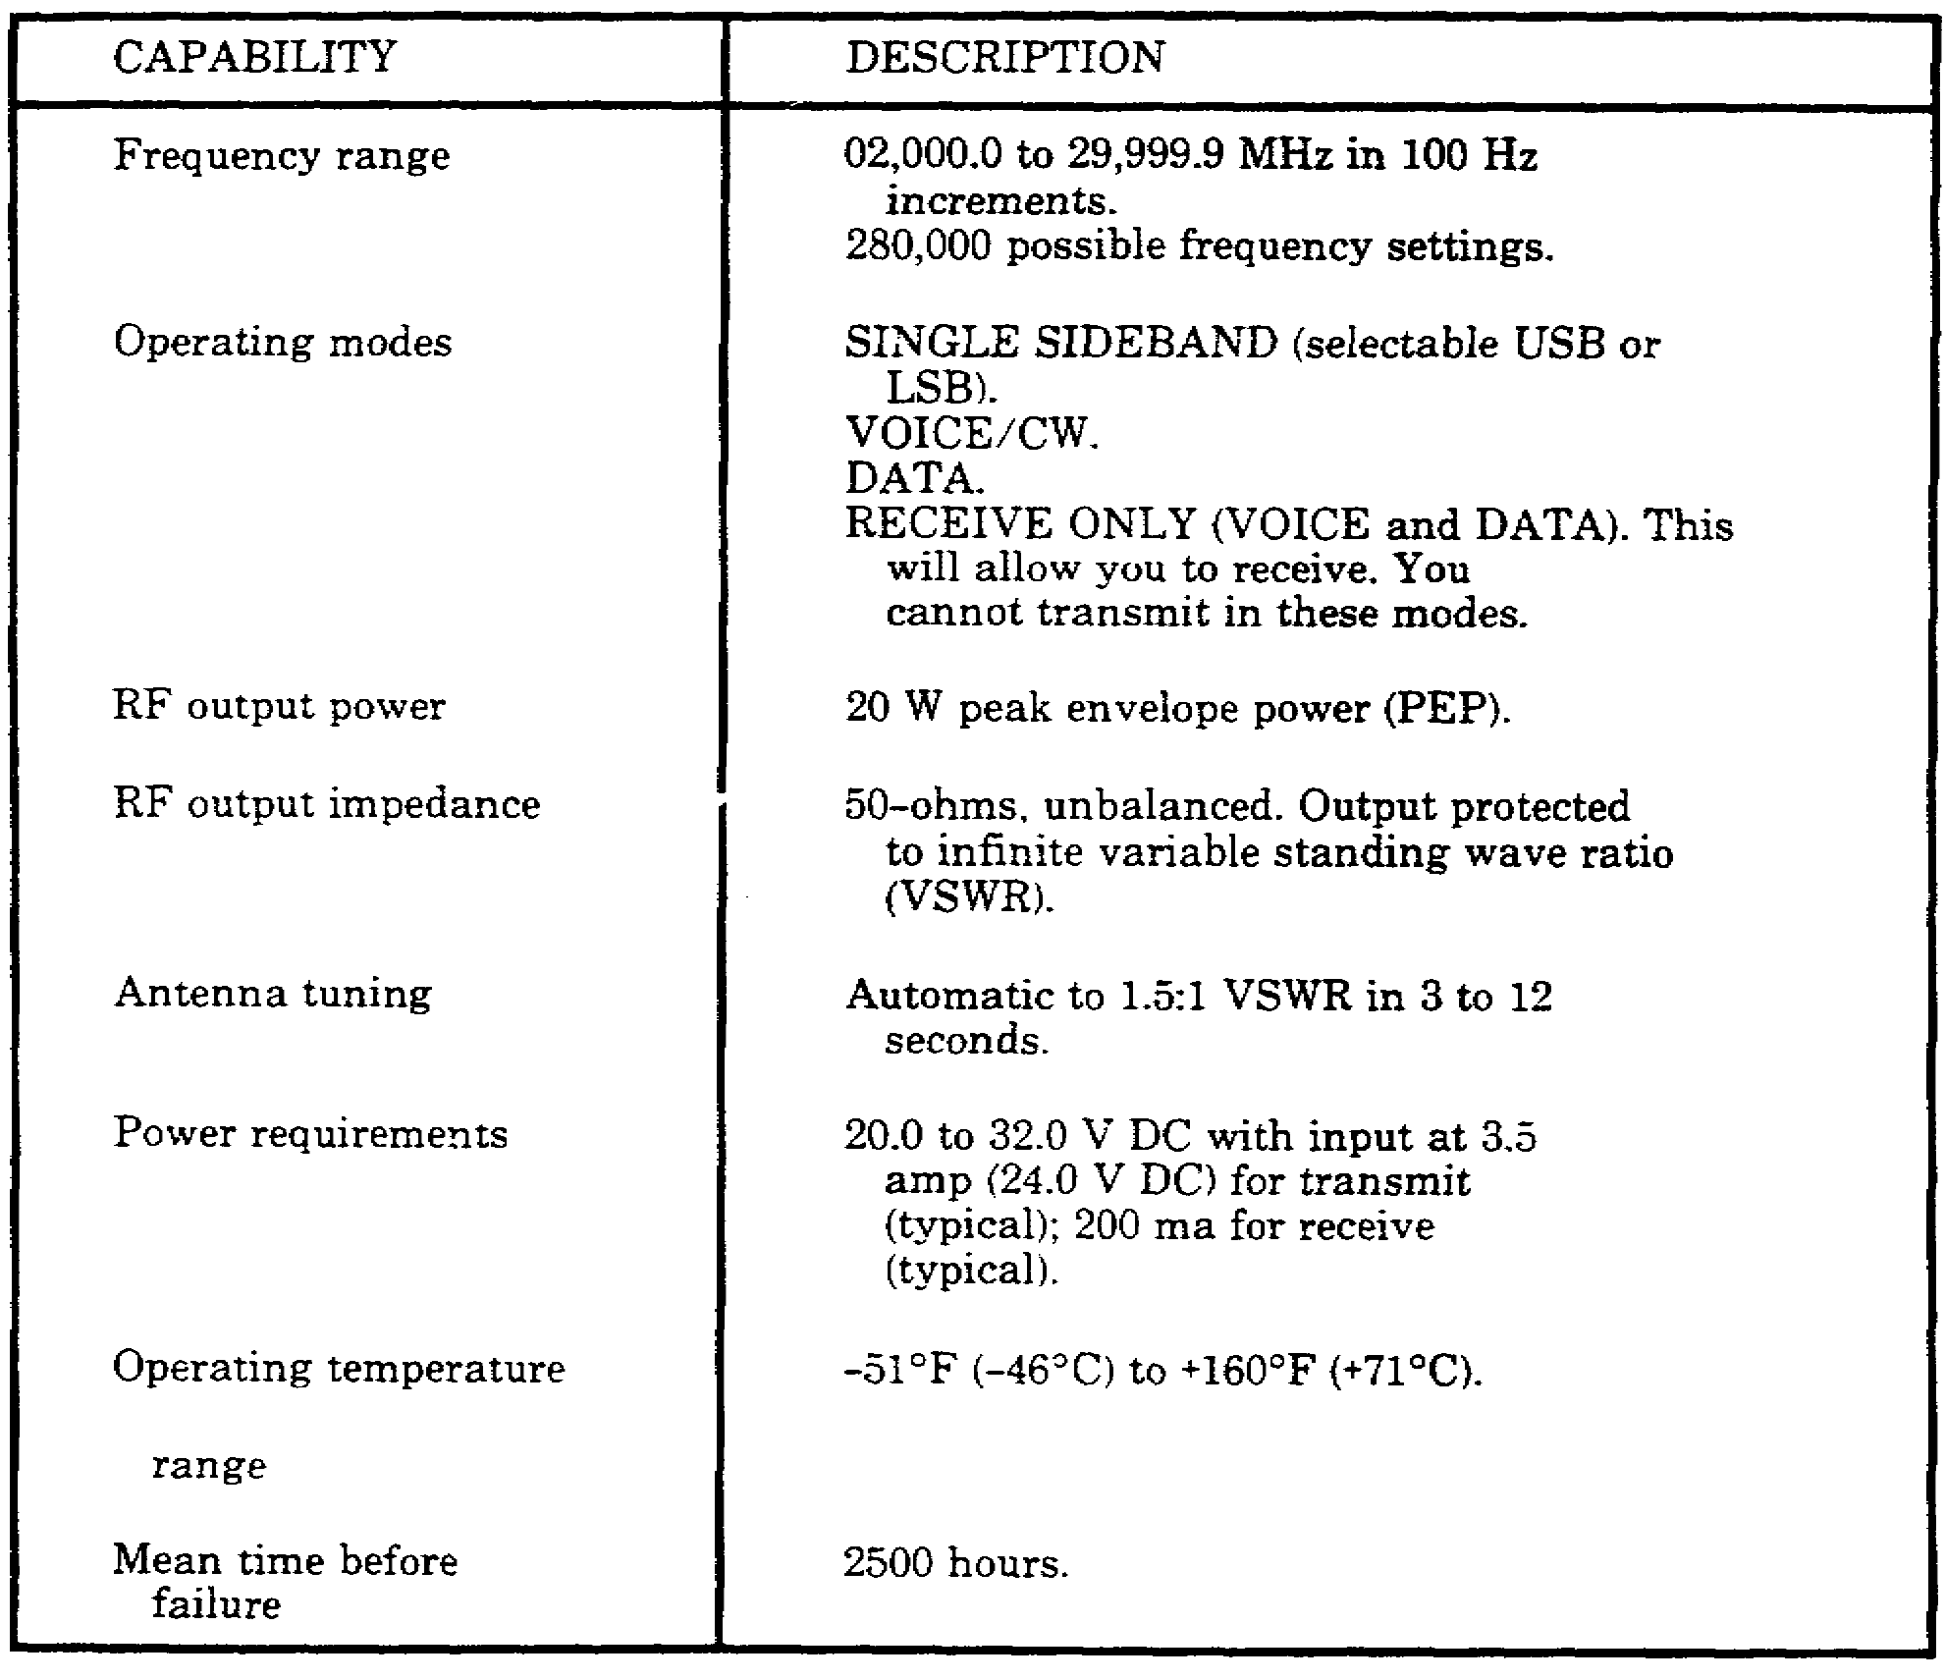

10

PRACTICE EXERCISES:

Complete the following exercises by circling T for true or F for false, circling the letter preceding the correct answer, or filling in the blanks, as appropriate. Be sure to complete the practice exercises as they appear. They are “building blocks” and will help you complete the rest of the subcourse successfully. The answers follow the last exercises and are separated by rows of slashes (/ / / / /). If any of your answers are incorrect, restudy the appropriate part of the subcourse before you continue.

1. The three major components of the AN/PRC-104 are the __________, __________, and __________.

a. RT-1209, H-250, CY-7541.
b. RT-1209, AM-6874, CY-7875.
c. RT-1209, AM-6874, CY-7542.
d. RT-1209, KY-872, CY-7542.

2. The AN/PRC-104 can operate on any frequency from __________ to __________ MHz.

a. 02,000.0 to 15,000.0
b. 02,000.0 to 24,999.9
c. 02,000.0 to 29,999.9
d. 02,000.0 to 35,000.0

3. The antenna that is used for normal manpack operation of the AN/PRC-104 is the--

a. whip antenna.
b. high-frequency broadband antenna.
c. FM narrow-band antenna.
d. NVIS antenna.

4. The RF output power of the AN/PRC-104 is ___________ watts.

a. 500
b. 100
c. 40
d. 20

5. The AN/PRC-104 will tune to an antenna in __________ to __________ seconds.

a. 3 to 12
b. 12 to 20
c. 20 to 28
d. 12 to 24

11

/ / / / / / / / / / / / / / / / / / / / / / / / / / / / / / / / / / / / / / / / / / / / / / / / / / / / / / / / / / / / / / / / / / / / / / / / / / / / / / / / / / / / / / /

ANSWERS:

1. b
2. c.
3. a.
4. d.
5. a.

/ / / / / / / / / / / / / / / / / / / / / / / / / / / / / / / / / / / / / / / / / / / / / / / / / / / / / / / / / / / / / / / / / / / / / / / / / / / / / / / / / / / / / / /

5. SUMMARY. During this lesson, you have learned the basic components, capabilities, and auxiliary equipment of AN/PRC-104.

a. This radio set is a tactical, manpack, state-of-the-art, battery-powered, lightweight radio transceiver that operates in the high-frequency and upper part of the low-frequency portions of the radio spectrum.

b. The basic components of radio set AN/PRC-104 are:

• Receiver-transmitter RT-1209.

• A 20-watt radio frequency amplifier AM-6874/PRC-104A (amplifier/coupler).

• Transit case CY-7875/PRC-104.

12

Lesson 2
INSTALL AND OPERATE RADIO SET AN/PRC-104

OBJECTIVE

Upon completion of this lesson, you will be able to install and operate radio set AN/PRC-104

REFERENCES

This lesson is based on the contents of TM 11-5820-919-12 and other materials approved for US Army instruction. However, development and progress render the text continually subject to change. Therefore, base your examination answers on material presented in this lesson rather than on individual or unit experience.

6. INTRODUCTION. This lesson will provide you with step-by-step instructions needed to properly install and operate radio set AN/PRC-104. The radio set and its components are contained, transported, and stored in radio set case CY-8291/PRC-104 (transit case). The transit case normally should be kept closed. To unpack the equipment, unfasten the four latches and remove the transit case cover. Each of the individual pieces of equipment fits in a molded space. Upon receiving this radio set, check that the equipment is complete and inspect the equipment for any damage incurred during shipment. In this lesson, you also will learn where the operator's controls and indicators are, what they do, and how to make required settings for operation. Finally, you will learn how to do an initial operational check of the radio set.

7. ASSEMBLING PROCEDURES. Before you can operate a radio set, it must be installed, so you will install the radio set first. To see how the radio set is to be assembled, see Figure 6.

a. Press the pressure relief valve button to equalize pressure before unlatching transit case, and then unfasten the four latches securing the cover to the transit case and remove the cover.

b. Remove the receiver/transmitter-amplifier/coupler combination from the transit case, and assemble them together. Ensure that the connectors on the two pieces are completely engaged by pressing the two together from the ends. Secure the two together by using the quick-disconnect latches located on the front and the rear of the amplifier/coupler. Tighten the latches until they are snug.

c. Attach the battery pack to the bottom of the receiver/exciter and the amplifier/coupler. You must make sure that the connectors on the battery pack and the amplifier/coupler are lined up. This is where the electrical connections are made for the battery. Secure the assembly by using the quick-disconnect latches on the battery pack. There are two of them.

d. Next, you should assemble the whip antenna. Screw the antenna base (shock mount) to the whip antenna, and then screw this assembly to the radio set at the antenna socket.

e. Connect a handset to the radio set audio connector.

13

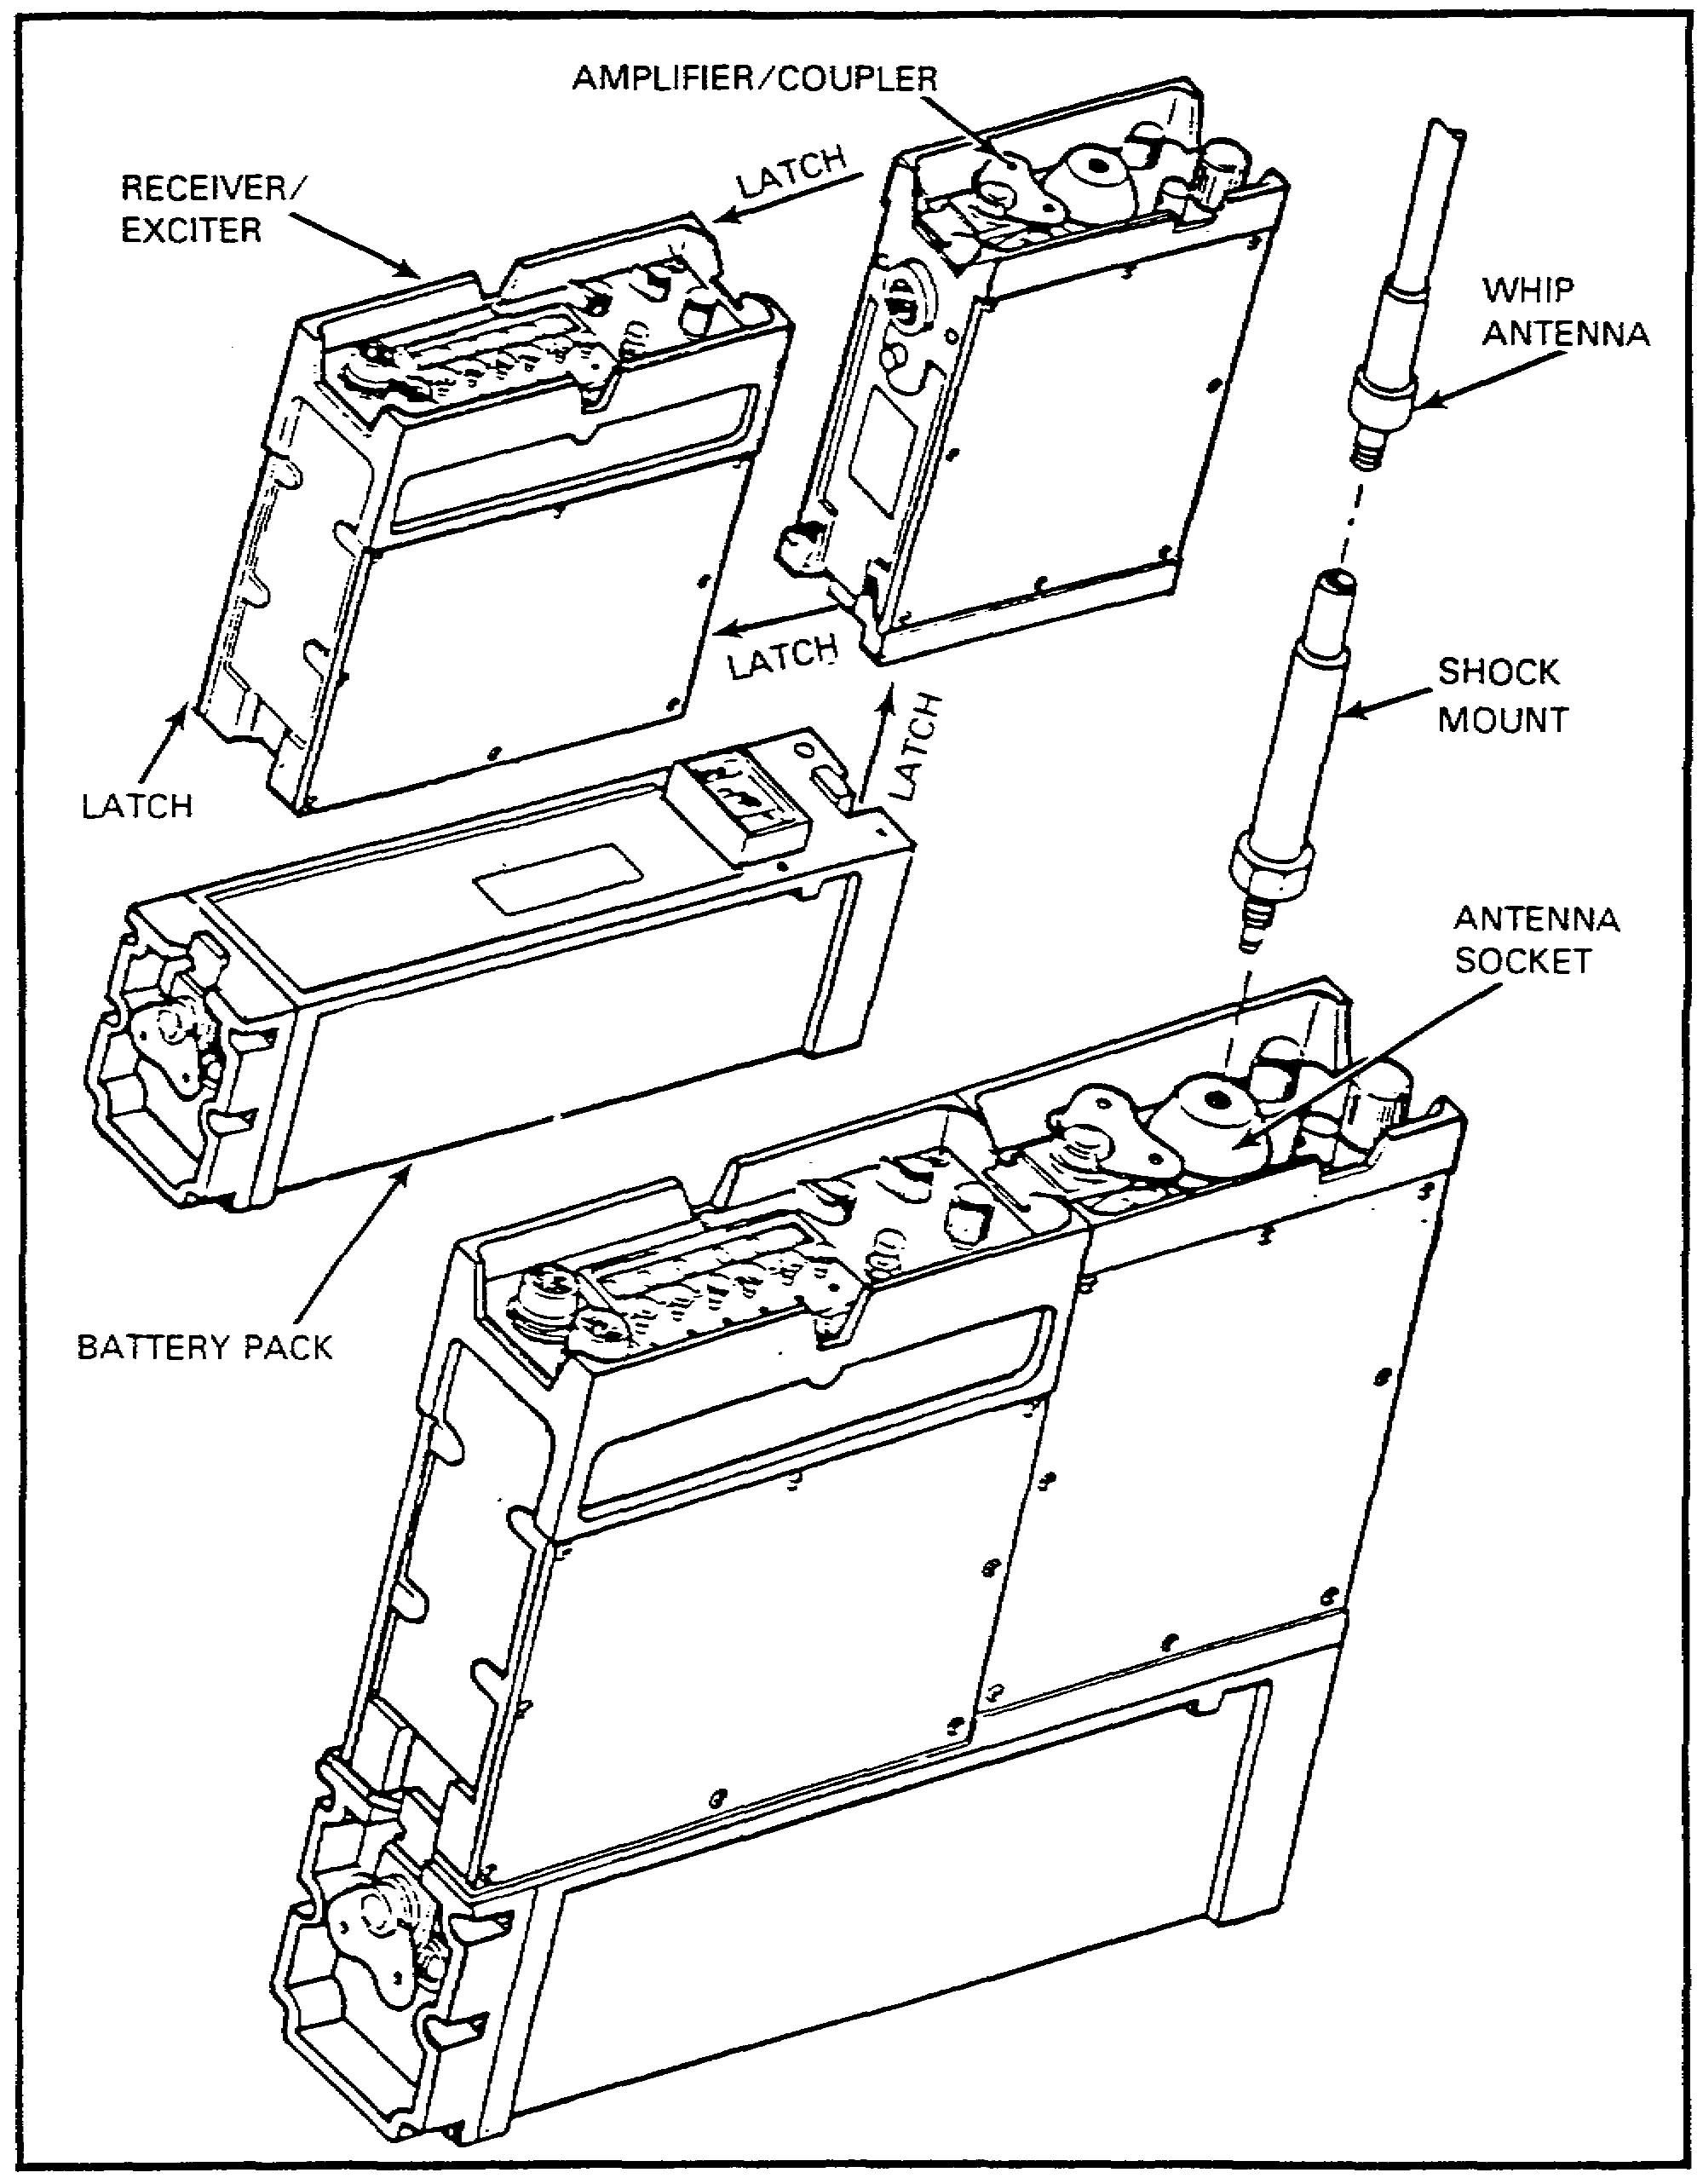

Figure 6. Radio set AN/PRC-104 installation and setup.

14

8. OPERATOR'S CONTROLS AND INDICATORS. The radio set is now assembled. Now you will learn the controls and indicators on the radio set, their functions, and how to use them.

a. The AN/PRC-104 controls are located on the front panels of the receiver/exciter and amplifier/coupler. The exception to this is the audible indicators. These are heard in the handset. The controls and indicators that are on the front panels are identified and described in Table 3, and the locations are shown in Figure 7.

Table 3. AN/PRC-104 controls and indicators.

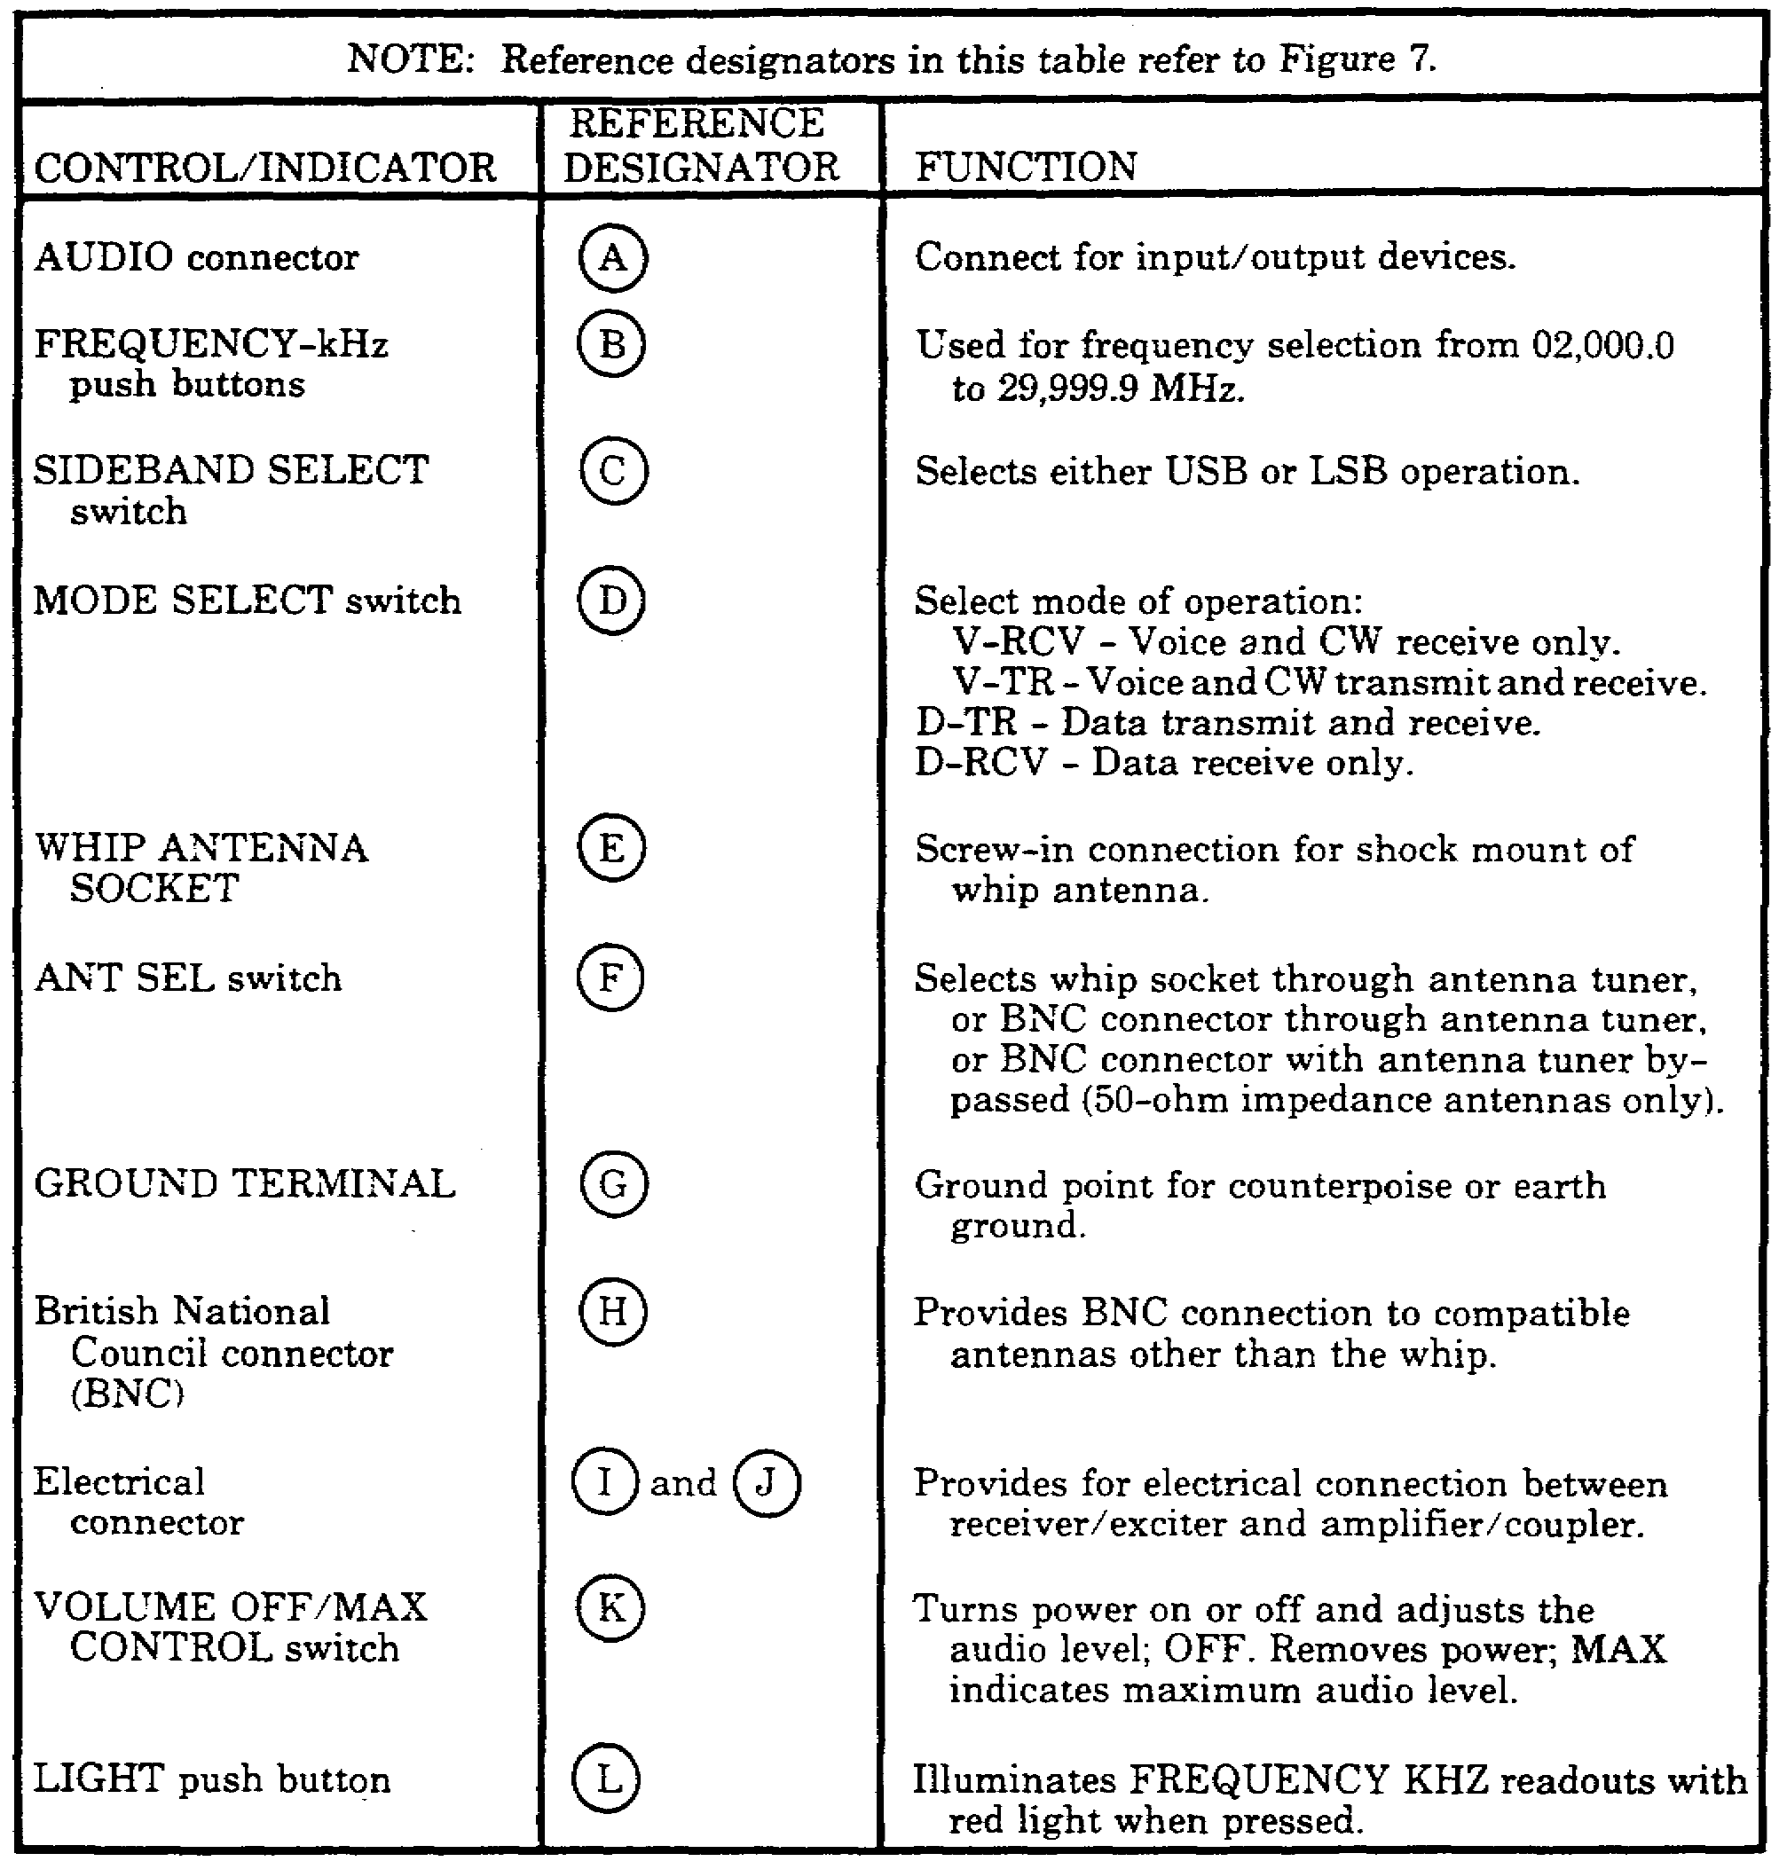

15

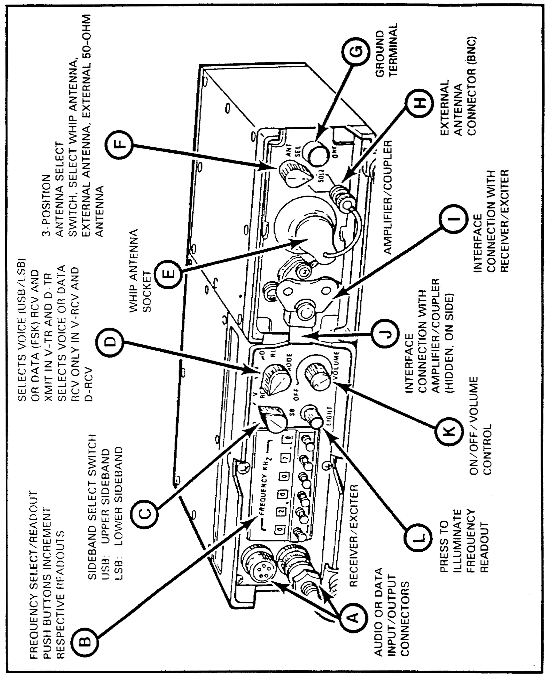

Figure 7. AN/PRC-104 controls and indicators.

16

b. There are five distinctive audible indicators that you need to become familiar with. These audible indicators will let you know what the operational condition of the radio set is.

(1) Low battery indicator. A repetitive clicking sound will be heard over the attached audio accessory when the battery voltage has fallen below 20 volts and when the battery is nearly exhausted. It first will be heard during a tune-up or voice transmission and will stop when you release the push-to-talk (PTT) switch. At this point, the battery has enough power left in it to let you transmit very briefly. When the alarm sounds continuously even while in the receive mode, you must replace the battery and have the drained battery recharged.

(2) Power output indicator. If while you are transmitting you hear your voice in the handset earpiece, you are hearing what is called sidetone. If you hear this sidetone, the radio set is putting out an RF signal. The absence of this sidetone indicates that you are not transmitting or you have a bad handset.

(3) Tuning indicator. If you have the ANT SEL switch in the BNC or WHIP position and the radio has been turned on or you have just changed frequency, the tuning operation will begin the first time the PTT switch is pressed. A continuous 1-kilohertz (kHz) tone will be heard in the handset. When this tone starts, you can release the PTT switch, and the radio set will tune itself. The tone will be heard until the radio has tuned itself. When the tone stops and the noise level increases, the antenna and radio set are matched. If the tone stops but the receiver noise level does not increase, the radio set is bad.

(4) No-tune indicator. If the tuning tone continues for a very long time (8 to 12 seconds) and a beeping tone is heard after the tuning tone ceases, the tuner has failed to tune and a tune fault has occurred. Shut the radio off, and turn it back on. Press the PTT switch again, and see if it will tune. If you get the beeping tone again, you have a faulty antenna or the antenna is not suitable for the selected frequency.

(5) VSWR indicator. If while you are transmitting (or before you attempt to transmit after you have been receiving) your antenna is changed (or the immediate environment of the antenna is changed. Its impedance will change and a high VSWR will result. The tuner will measure the VSWR when the PTT switch is pressed and will retune if the impedance change is permanent. A short beep will be heard at the beginning of the transmission if the VSWR mismatch was temporary. There will be no retune in this case.

c. Table 4 gives you a handy guide to use when the radio set AN/PRC-104 is not operating properly.

17

Table 4. Fault indication by audible tones.

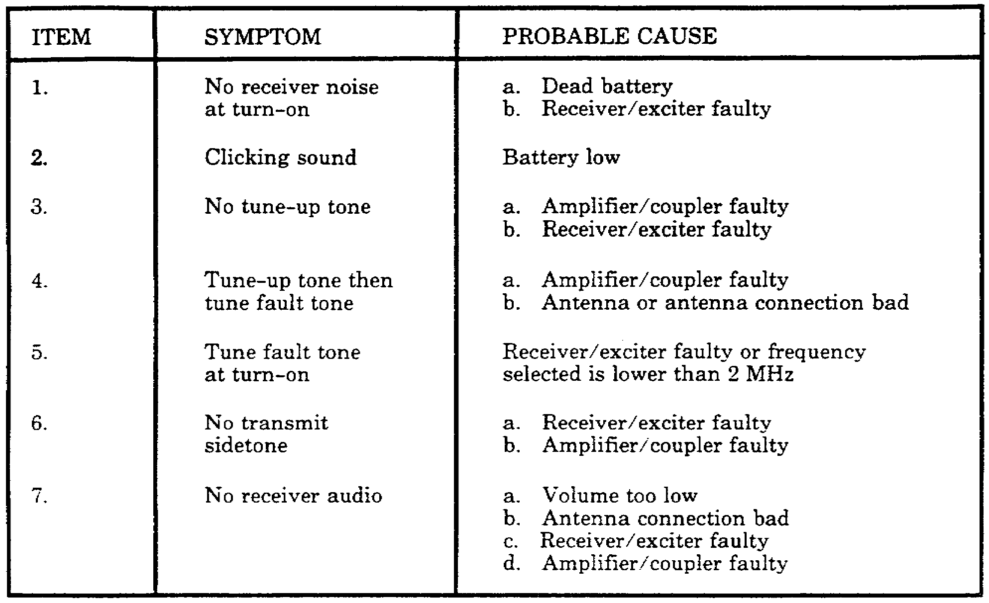

18

9. PRELIMINARY SETUP. Now that you have learned how to install the radio set and where the operator's controls and indicators are, you are ready to perform the preliminary setup of the AN/PRC-104. Set the radio set controls as follows:

• Turn MODE switch to V-TR.

• Turn ANT SEL switch to WHIP connection position.

• Set FREQUENCY to a frequency authorized by your frequency manager.

• Turn sideband select switch to USB.

• Turn VOLUME control clockwise to apply power, and set to desired listening level. (If a clicking sound is heard, this indicates a weak battery [20 V or less, replace battery]).

• Press PTT button on the handset. The radio set will do its tuning procedure.

10. TEST PROCEDURES. When the radio has concluded its tuning procedure, you will be ready to begin operating the radio set. You should perform an operational test on the radio at this point. The test procedures are as follows:

• Change frequency by at least 1 kHz; then momentarily press the handset PTT switch.

• Listen for a 1-kHz tune tone. (Tuning is brief; it may be 3 to 12 seconds.)

NOTE: Tune tone should terminate within 12 seconds. This indicates the automatic antenna tuner is operating normally. A continuous, rapid beeping sound in the handset indicates failure of the radio to properly tune (a tuning fault exists).

• Transmit by using the handset. Press the PTT switch, and communicate with another radio set on the test frequency. The presence of sidetone in the handset earpiece indicates transmission is satisfactory. (If fault tone occurs, refer to the radio troubleshooting procedure.)

• Repeat the above procedures for test frequencies, spaced through the 2- to 30-MHz part of the radio spectrum to test the auto tune feature. These frequencies can be obtained from your frequency manager.

• Select a frequency for the time standard broadcast (multiples of 5 MHz; e.g., 5, 10, 15, 20 MHz). For this test, one frequency may be better than another depending on the time of day and station. You may not hear these stations if you are located outside the United States.

NOTE: Some frequencies may not work at all, so try several if necessary to get a good signal.

19

• Monitor the time standard broadcast and switch sidebands. Verify that the pitch of the audible signal does not change. This indicates the frequency accuracy of the radio set is within specifications.

• Turn the radio off. The test is completed. The radio set is good.

11. OPERATING PROCEDURES.

a. Now that you have performed the operation test on the AN/PRC-104, you are ready to operate it. Set the controls as follows:

• Turn MODE switch to V-TR.

• Turn sideband select switch to USB or LSB (as appropriate).

• Set FREQUENCY to your net operating frequency (see SOI).

• Turn ANT SEL switch to WHIP antenna.

• Turn VOLUME control to desired listening level. Power is applied at this time through the VOLUME control.

NOTE: If a clicking sound is heard, this indicates a weak battery (20 V or less), and the battery needs to be replaced.

• Momentarily press the handset PTT switch.

• Listen for a 1-kHz tune-up tone. Tuning is brief; it may be 3 to 12 seconds.

NOTE: Tune tone should terminate within 12 seconds. This indicates the radio is tuned and ready for operation. A continuous, rapid beeping in the handset indicates failure of the radio to properly tune (a tune fault exists). (Refer to troubleshooting procedures or to organizational maintenance.)

b. To communicate with the AN/PRC-104, use the handset as follows:

• Press the PTT switch, transmit to another station, and release the PTT switch to hear (receive) the other station.

• Press to transmit, and release to listen.

• Listen for sidetone in the handset earpiece. Its presence indicates you are transmitting.

12. DISASSEMBLY AND TRANSPORT PROCEDURES. Now that you know how to operate the radio set, you are ready to learn how to disassemble and transport it.

20

To disassemble and transport the radio set, use the following procedures:

• Turn power off.

• Remove the antenna and antenna shock mount (base) from the radio set.

• Remove the antenna shock mount (base) from the antenna, and place the base in the space provided in the transit case.

• Starting at the tip (top end), fold the seven-section antenna, and place it in the transit case.

• Remove the handset, and place it in the transit case.

• Remove the battery pack from the receiver/transmitter-amplifier/coupler. Do not place the battery pack in the transit case. Batteries must be removed from the battery case and transported separately.



ONLY BATTERY PACKS THAT ARE NOT ACTIVATED MAY BE PLACED IN THE TRANSIT CASE. AN ACTIVATED BATTERY PACK MUST BE TRANSPORTED AND STORED SEPARATELY.

• Place the receiver/transmitter-amplifier/coupler combination in the transit case.

• Replace the transit cover, and fasten the four latches.

NOTE: The radio set is now ready for transport or storage.

13. SUMMARY. In this lesson, you learned how to install and operate the radio set AN/PRC-104.

a. You also learned where the operator's controls and indicators are, what they do, and how to make the required settings for operation.

b. Finally, you learned how to do an initial operational check of the radio set.

21

Lesson 3
PERFORM OPERATOR'S MAINTENANCE CHECKS AND SERVICES

OBJECTIVE

After completing this lesson, you will be able to perform operator's preventive maintenance checks and services (PMCS) on radio set AN/PRC-104.

REFERENCES

This subcourse is based on the contents of TM 11-5820-919-12 and other materials approved for US Army instruction. However, development and progress render the text continually subject to change. Therefore, base your examination answers on material presented in this subcourse rather than on individual or unit experience.

14. INTRODUCTION. Preventive maintenance is the systematic inspection and servicing of the radio set to prevent equipment failure. This reduces downtime and ensures that the radio set is fully mission capable when needed. This lesson contains daily and weekly checks and services, cleaning instructions, and corrosion control instructions.

15. OPERATOR'S DAILY AND WEEKLY PMCS. As the operator, you are responsible for daily and weekly PMCS. Although not mentioned specifically as either daily or weekly PMCS, you also are required to keep the radio set clean. You should keep in mind that the reason you pull the PMCS is so you can keep your radio set operational. Keeping the radio set clean is just as important.

a. The radio set should be cleaned whenever it is necessary. You should do the following:

• Remove dirt, dust, grease, or other debris from external surfaces by using a cloth or brush moistened in clear water. Dry the equipment with a soft, lint-free cloth.

• Clean any dust or dirt from the connectors and pins with a soft-bristled brush.

b. The daily and weekly PMCS are listed in Table 5. The operator will perform the daily PMCS when the equipment is operated. The operator will perform weekly PMCS if the equipment is not operated daily. However, daily PMCS also is performed whenever weekly PMCS is performed. When you are performing PMCS and you find items that are broken or damaged beyond repair, report it to the next higher maintenance level. Any deficiencies you can't correct must be reported on DA Form 2404.

NOTE: Operator's PMCS should be performed before, during, and after operations as appropriate with the checks or services to be performed.

23

Table 5. Operator's daily and weekly PMCS.

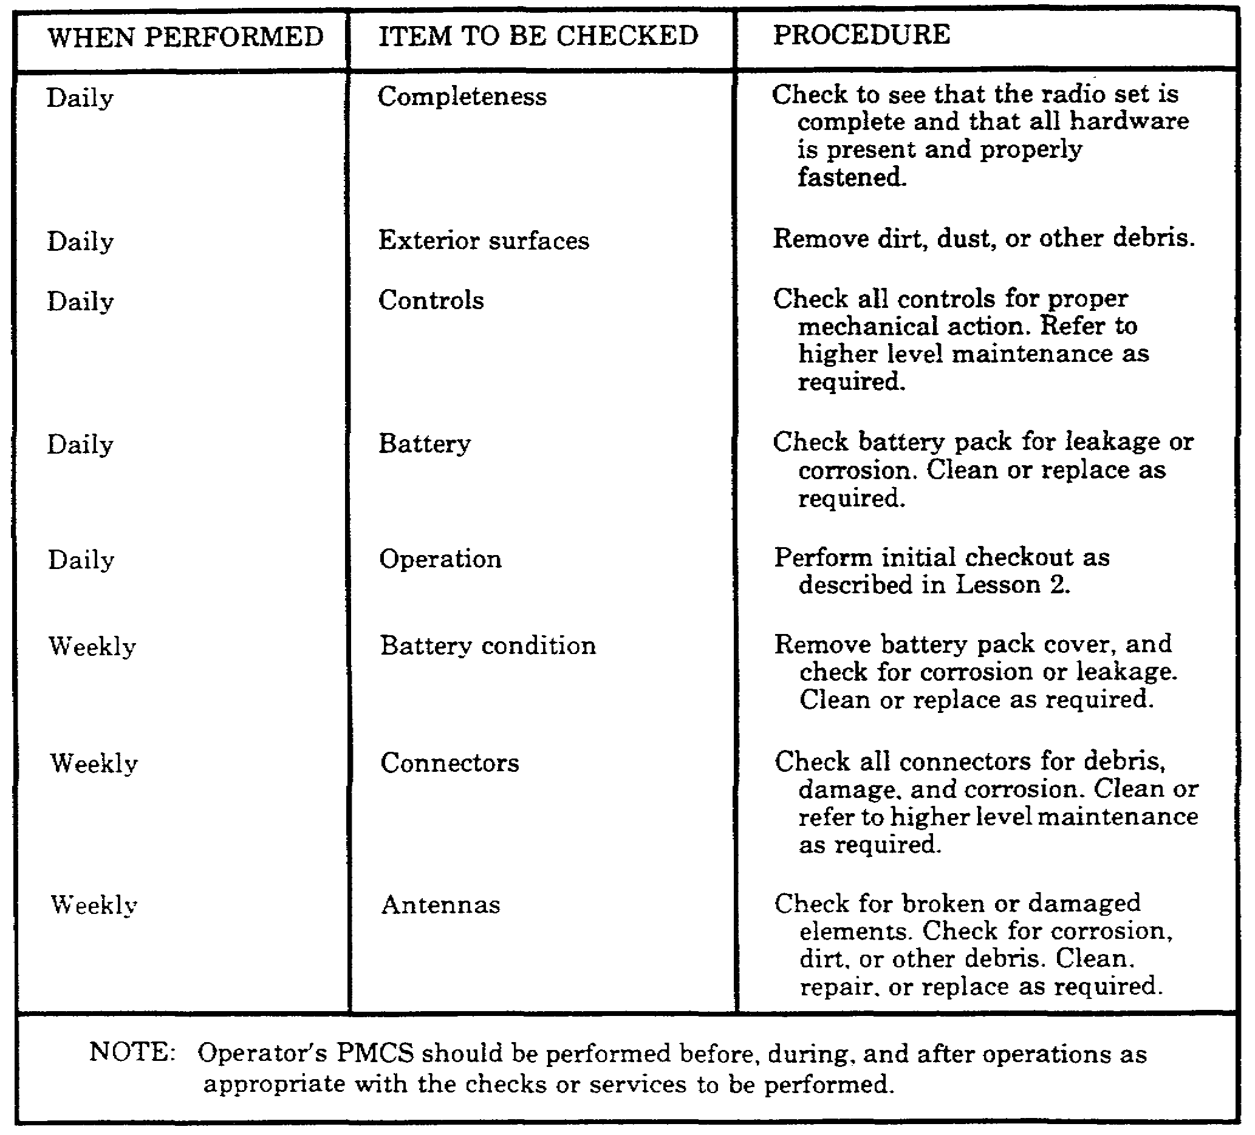

24

16. CORROSION CONTROL. You should check for any corrosion or fungus on the radio set whenever you are operating it or preparing it for operation. When you perform PMCS, you should separate the three units if they are installed and check the exterior surface controls and connectors for any signs of corrosion or fungus. If you see any signs of this, you should remove it with a cloth and/or brush moistened in cleaning solvent. Repaint any surfaces that need painting.

17. SUMMARY. In this lesson, you have learned how to perform the daily and weekly checks and services, how to clean the radio set, and what measures you can take to control corrosion. The performance of maintenance on this radio set is very important. It can mean the difference between life and death in some instances. As a result, you should place emphasis on the performance of the maintenance on this and all radio sets.

25

Lesson 4
IDENTIFY THE COMPONENTS AND STATE THE CHARACTERISTICS
AND CAPABILITIES OF RADIO SET AN/GRC-213

OBJECTIVE

After completing this lesson, you will be able to identify the components and state the characteristics and capabilities of radio set AN/GRC-213.

REFERENCES

This lesson is based on the contents of TM 11-5820-923-12 and other materials approved for US Army instruction. However, development and progress render the text continually subject to change. Therefore, base your examination answers on material presented in this lesson rather than on individual or unit experience.

18. INTRODUCTION. In this lesson, you will learn the components, characteristics, capabilities, and equipment needed for operation of the radio set AN/GRC-213.

a. The AN/GRC-213 is a lightweight (50 lbs), low-power, HF radio set. It is used to provide you with reliable long-range communications for your wheeled or tracked vehicles. The AN/GRC-213 uses the AN/PRC-104A radio set (minus the battery pack) with an amplifier-power supply (AM-7152/GRC-213) to provide this vehicle-mounted system. The amplifier-power supply is connected to the vehicle power source through an electrical power cable CX-4720. The AM-7152 filters and conditions the vehicle power for the radio set. It also amplifies and squelches the audio output to drive an external speaker (LS-454) and provides connection for AN/VIC-1 intercom. Figure 8 will show you what the radio set looks like. It gives you a front and rear view of the radio set. Figure 9 shows you a front and rear view of the mount with SA-2365 antenna coupler attached.

b. The AN/GRC-213 is designed for ease of installation and removal from the mount. The latches are all quick-release and the connectors are all push-and-twist- or screw-type connectors. The AN/GRC-213 uses the same audible indicators as the AN/PRC-104A. The only lighted indicators you have are the power indication light on the AM-7152 and the frequency light in the RT-1209. You are able to dim these lights for operation under blackout conditions.

c. In some vehicles, equipment is provided for the amplifier-power supply to interface with the AN/VIC-1(V) and the very high frequency (VHF) FM radio set that is in those vehicles. This allows the capability of automatic retransmission. This capability will allow any remote HF SSB radio set to transmit to and receive from any remote VHF FM radio set through the AN 'GRC-213. AN /VIC-1(V), and VHF FM radio sets. This also will allow a remote VHF FM radio set to transmit to or receive from any remote HF SSB radio set through the VHF radio sets AN/VIC-1(V) and AN/GRC-213.

27

19. COMPONENTS AND CHARACTERISTICS. Now that you know the general description and capabilities of the radio set AN/GRC-213, you will learn its four major components (Figs 8 and 9). They are:

• RT-1209 receiver/exciter.

• AM-6874 amplifier/coupler.

• AM-7152 amplifier-power supply.

• SA-2365 antenna switching unit. When you receive the equipment, the antenna switching unit SA-2365 will not be packed with the rest of the radio set. It is part of the mount for the radio set.

28

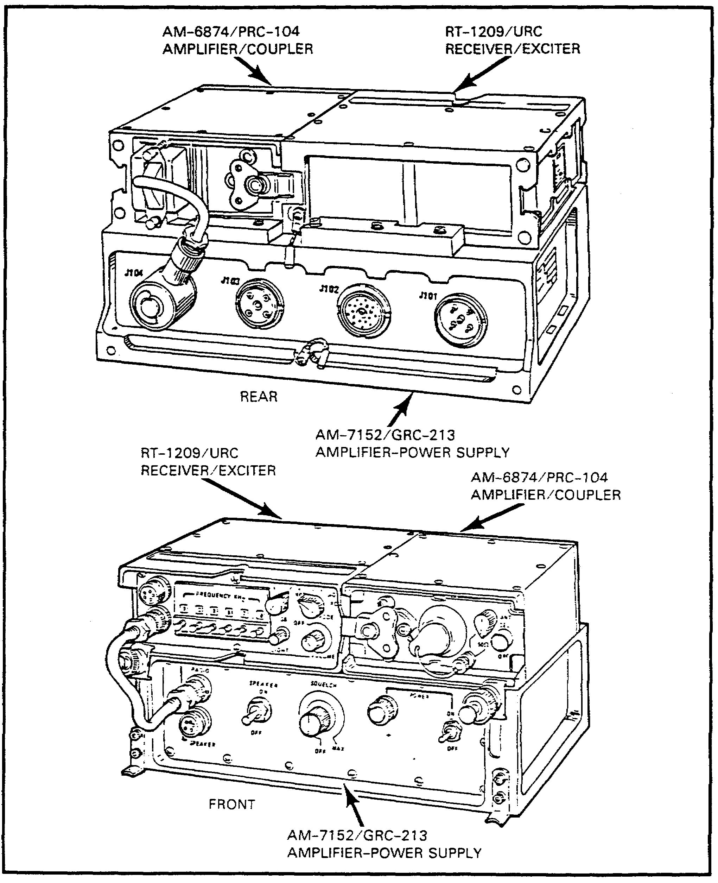

Figure 8. AN/GRC-213 front and rear views.

29

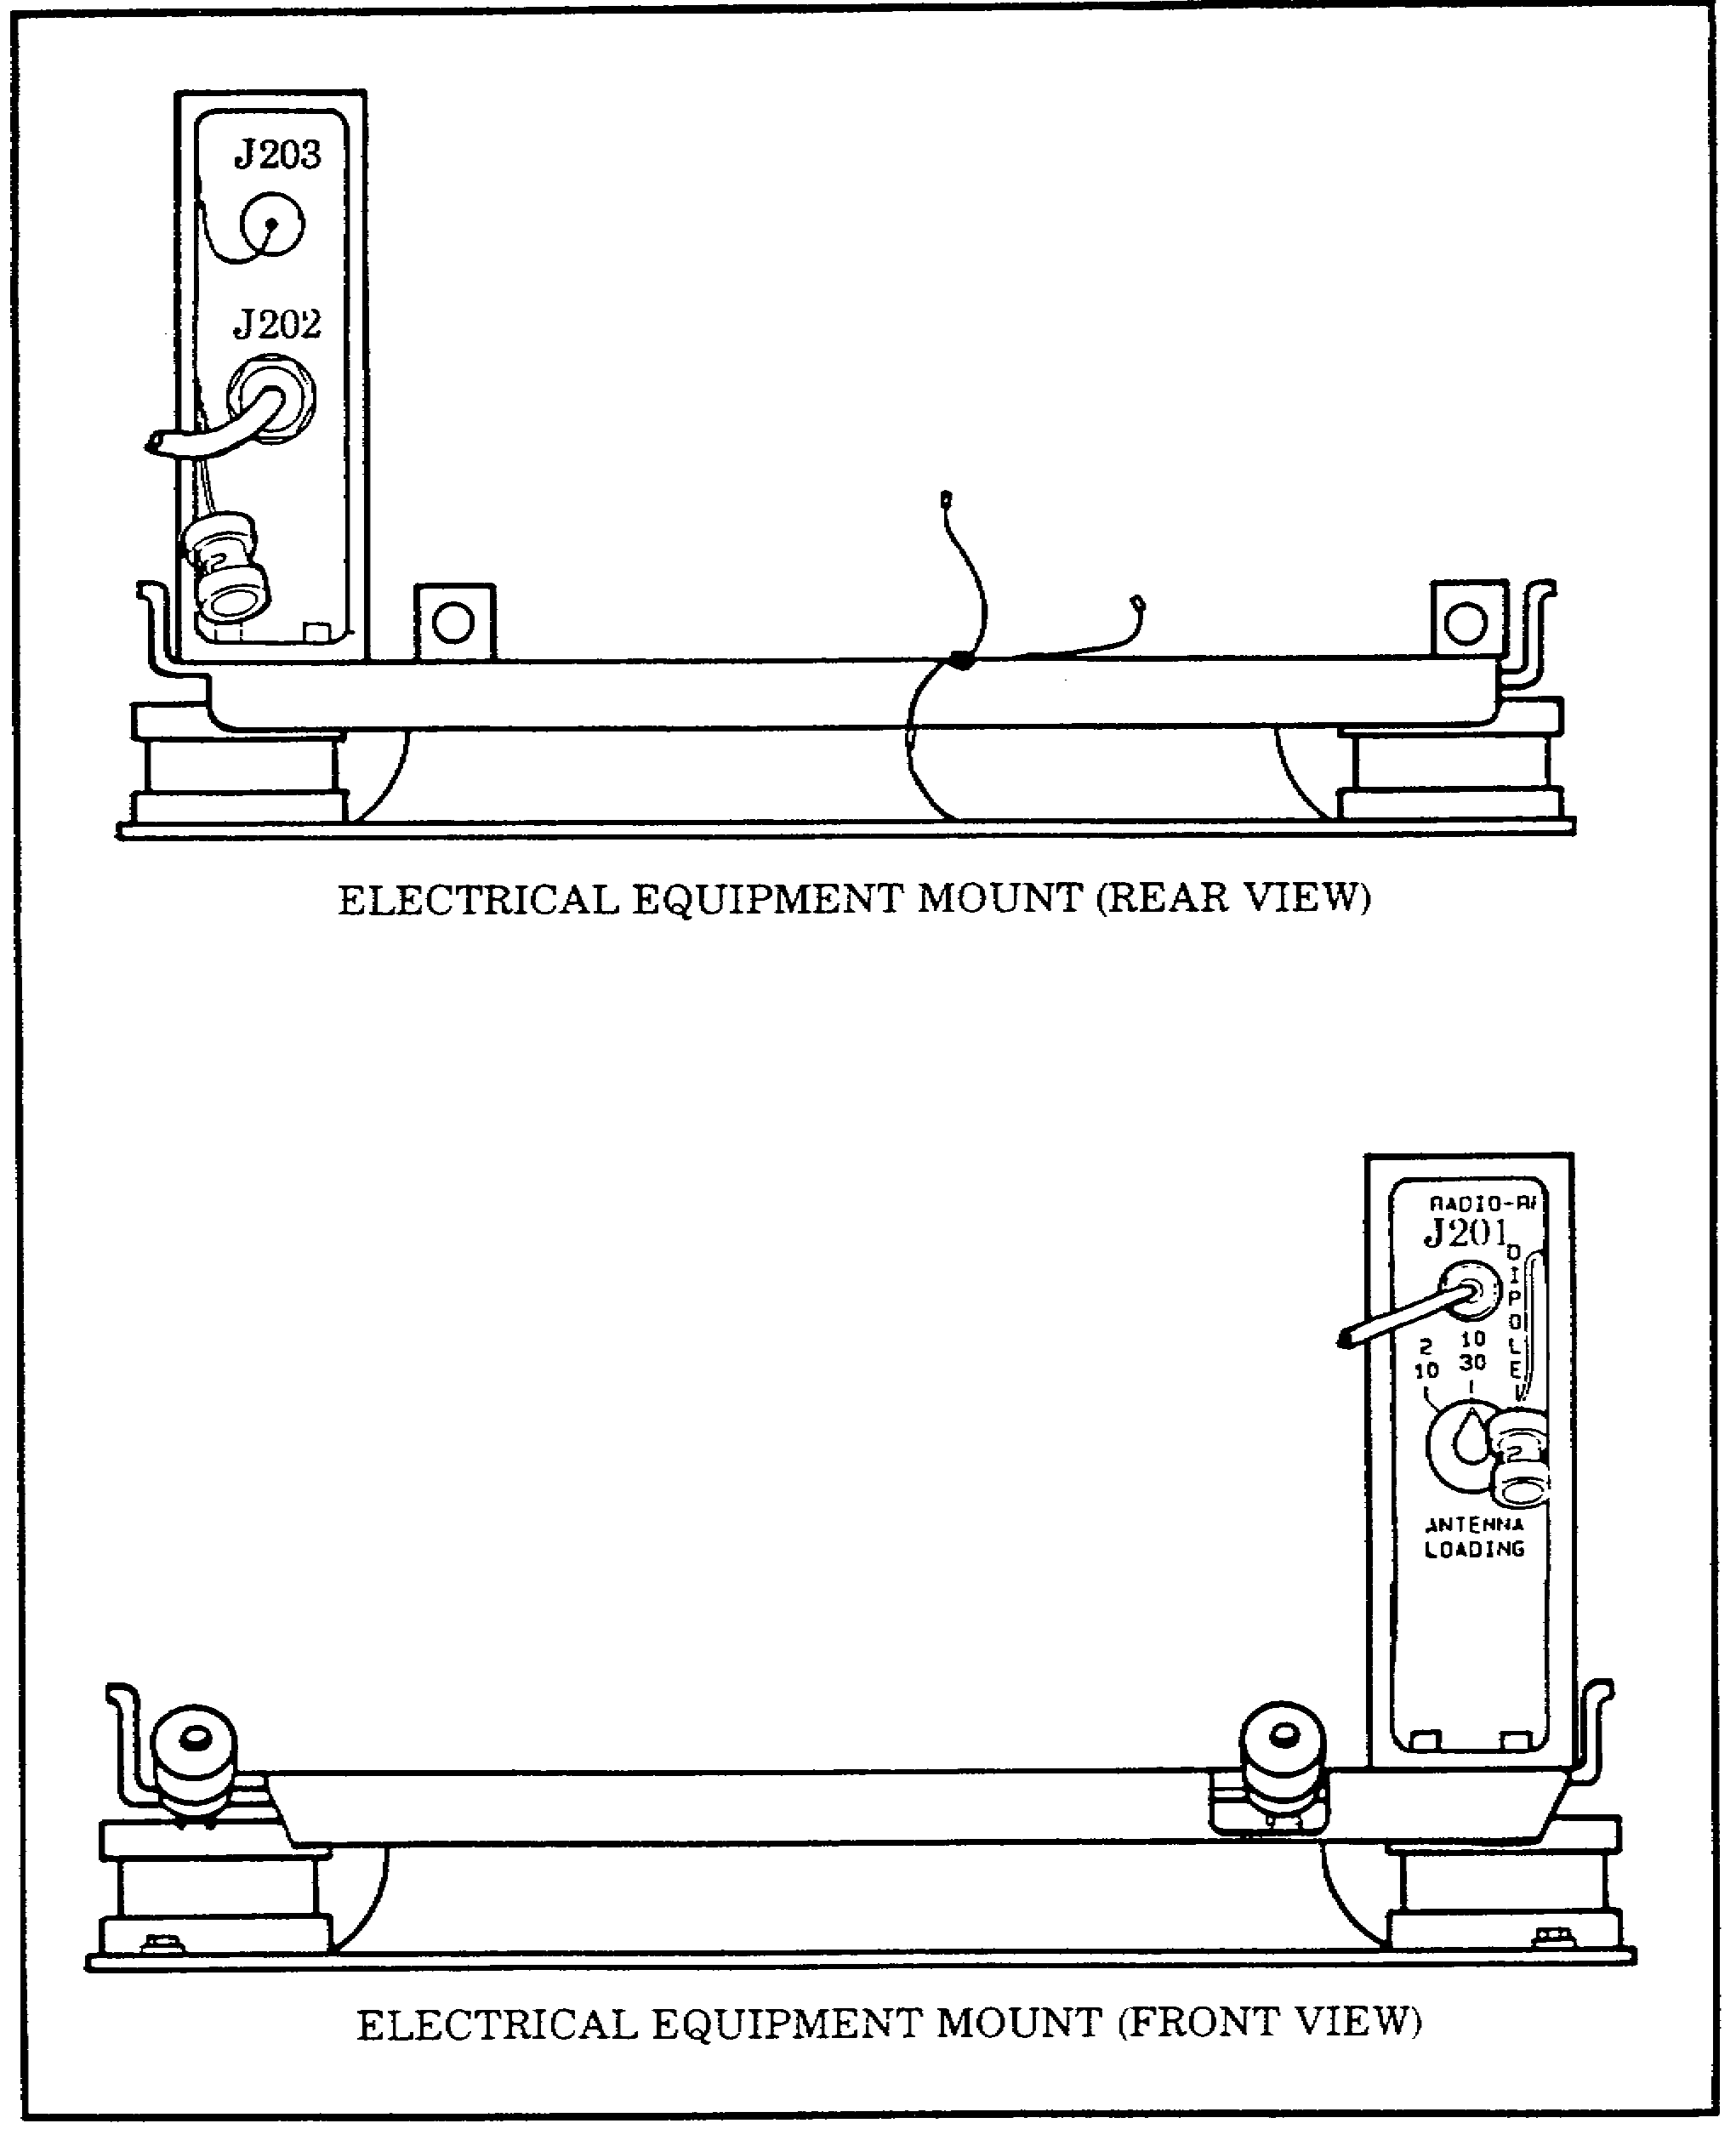

Figure 9. Front and rear views of mount and antenna switching unit SA-2365.

30

20. TECHNICAL CAPABILITIES. Now that you know the components, characteristics, and equipment needed for operation of radio set AN/GRC-213, next you will learn the technical capabilities for the radio set. It is important that you know its capabilities for the AN/GRC-213 are listed and described in Table 6.

Table 6. Technical capabilities.

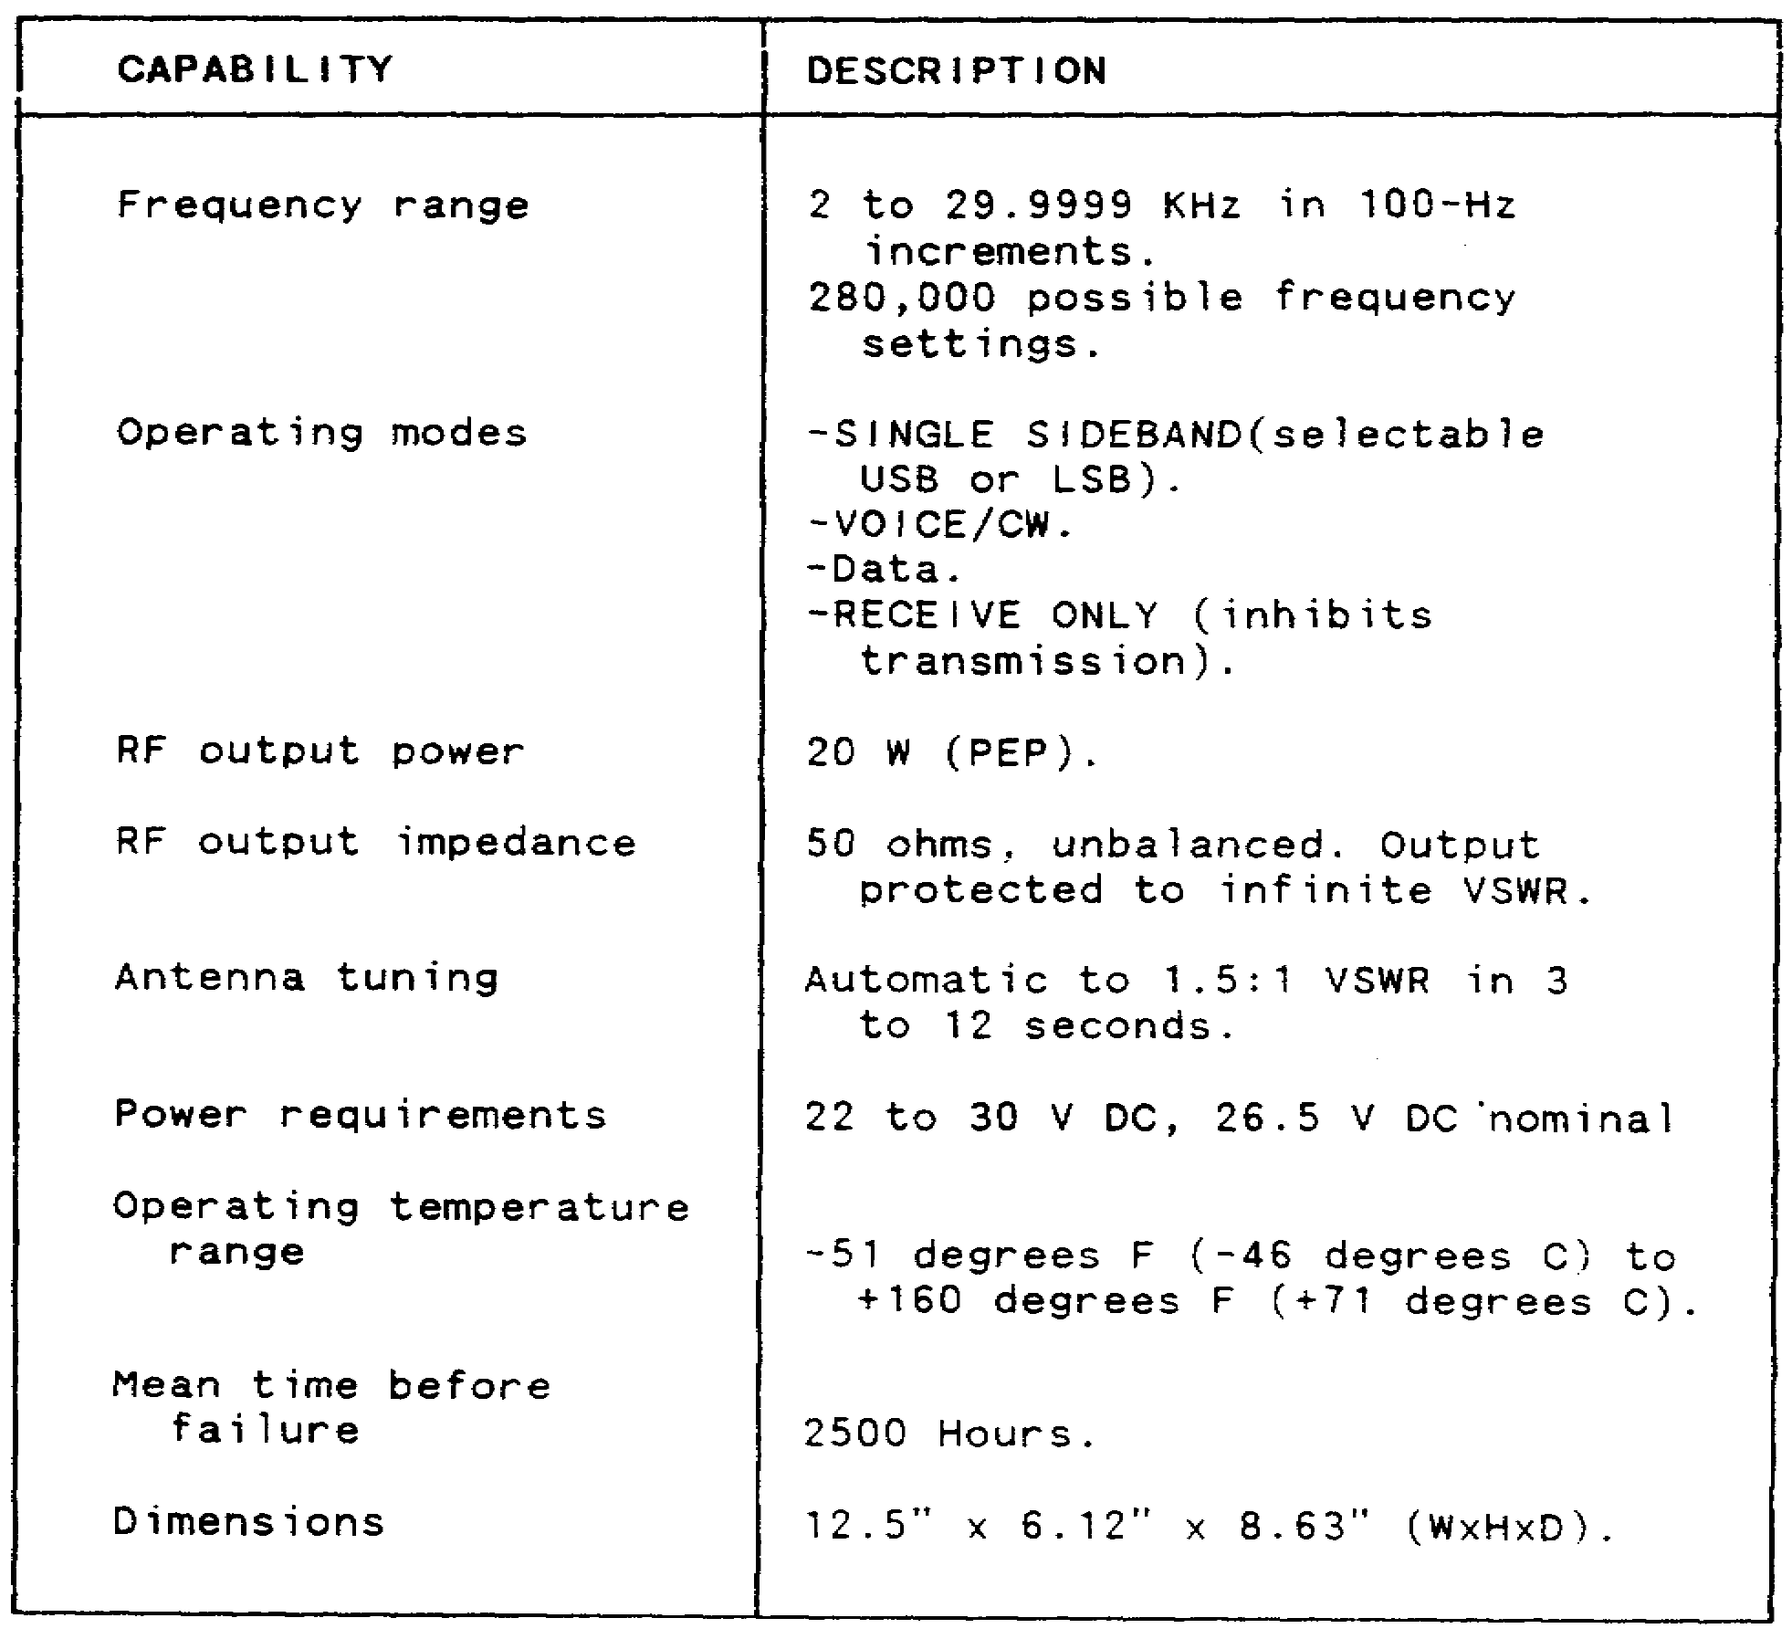

31

PRACTICE EXERCISES:

6. The four major components of radio set AN/GRC-213 are--

a. RT-1209, AM-6874, AM-7152, and SA-2365.
b. RT-524, AM-7468, AM-7152, and SA-2365.
c. RT-1209, AM-7468, AM-7152, and SA-236.
d. RT-524, AM-6874, AM-5271, and SA-623.

7. The required input voltage for operation of the AN/GRC-213 radio set is--

a. 12 to 24 V AC.
b. 30 to 36 V DC, 36.5 V DC nominal.
c. 115 to 208 V AC, 60 Hz.
d. 22 to 30 V DC, 26.5 V DC nominal.

8. The weight of the AN/GRC-213 radio set is--

a. 5.9 lbs.
b. 14 lbs.
c. 50 lbs.
d. 56 lbs.

9. The antennas used with radio set AN/GRC-213 are--

a. whip, slant wire, dipole, and NVIS.
b. broadband, slant wire, dipole, and NVIS.
c. whip, rhombic, slant wire, and NVIS.
d. whip, slant wire, broadband, and NVIS.

/ / / / / / / / / / / / / / / / / / / / / / / / / / / / / / / / / / / / / / / / / / / / / / / / / / / / / / / / / / / / / / / / / / / / / / / / / / / / / / / / / / / / / / /

ANSWERS:

6. a.
7. d.
8. c.
9. a.

/ / / / / / / / / / / / / / / / / / / / / / / / / / / / / / / / / / / / / / / / / / / / / / / / / / / / / / / / / / / / / / / / / / / / / / / / / / / / / / / / / / / / / / /

32

21. SUMMARY. In this lesson, you have learned the components, characteristics, capabilities, and equipment needed for operation of the radio set AN/GRC-213.

a. The AN/GRC-213 major components are:

• RT-1209 receiver/exciter.
• AM-6874 amplifier/coupler.
• AM-7152 amplifier-power supply.
• SA-2365 antenna switching unit.

b. As you can see, the AN/PRC-104 and the AN/GRC-213 are basically the same. The exceptions are the AM-7152 and some of the advantages these radio sets will give you in providing reliable short- and long-distance radio communications.

33

Lesson 5
INSTALLATION OF RADIO SET AN/GRC-213

OBJECTIVE

After completing this lesson, you will be able to install radio set AN/GRC-213 in a vehicle.

REFERENCES

This lesson is based on the contents of TM 11-5820-923-12 and other materials approved for US Army instruction. However, development and progress render the text continually subject to change. Therefore, base your examination answers on material presented in this lesson rather than on individual or unit experience.

22. INTRODUCTION. In this lesson, you will learn how to install the AN/GRC-213 onto a vehicular mount for operation as a stand-alone radio set. This lesson is very important, because before you can operate this radio, it must be installed properly.

23. INSTALLATION PROCEDURES. To mount the main components of the radio set, you should perform the following:

a. First you should ensure that you have a complete radio set.

b. Check the mount to ensure that it is properly installed into the vehicle (refer to TM 11-2300-76-14-P).

c. Connect and latch the amplifier/coupler and receiver/exciter units together (see Figure 10).

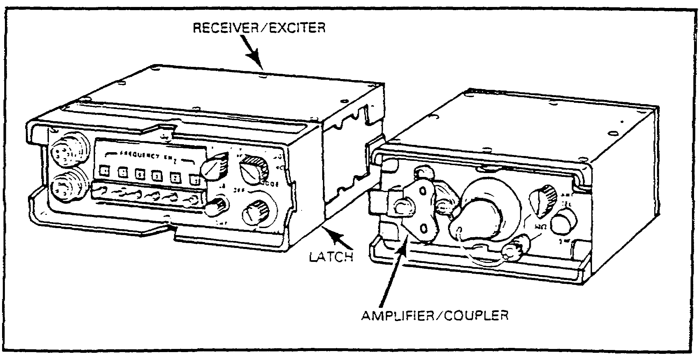

Figure 10. Latching of receiver/exciter and amplifier/coupler.

35

d. Place the latched units on top of the amplifier-power supply.

e. Slide the latched receiver/exciter and amplifier/coupler toward the rear of the amplifier-power supply. There are cleats on the back of the AM-7152 amplifier- power supply into which the receiver/exciter and amplifier/coupler should slide. If necessary, push them until they are fully seated.

f. Attach the two fasteners that are located on the front of the AM-7152 over the top of the catches on the receiver/exciter and amplifier/coupler. There is one on each of the two units. (Refer to Figure 11.) Tighten these fasteners until they are snug (finger tight) and the three units are securely latched together.

g. Now, slide this assembly into the mount and ensure that the guide pin holes on the rear bottom of the AM-7152 line up with and fully engage the guide pins on the mount.

h. Attach the bottom fasteners on the mount over the two catches on the front of the AM-7152, and secure them in the same manner as you did in step f.

36

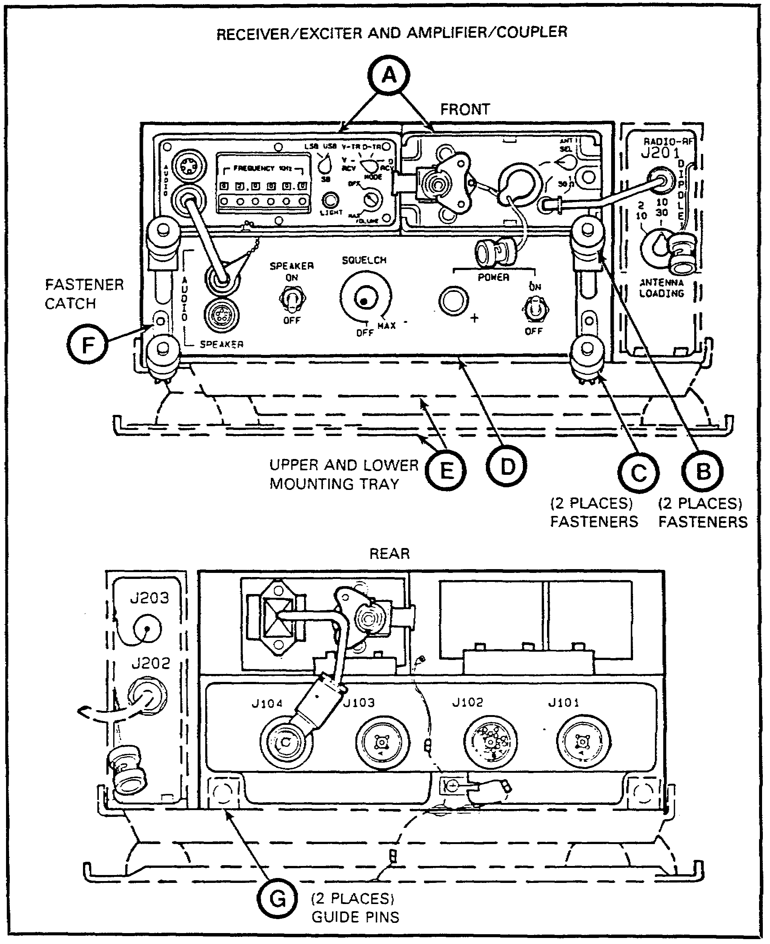

Figure 11. Mounting diagram for the receiver/exciter and amplifier/coupler.

37

24. ANTENNA CONNECTION. You now have the radio set mounted. Now you must make all the cable connections and attach the required auxiliary equipment.

CAUTION

VERIFY THAT POWER IS PROPERLY TURNED OFF BEFORE PROCEEDING. ELECTRICAL VOLTAGES WILL CAUSE BURNS IF CONTACT IS MADE WITH THE ANTENNA AND THE RADIO IS KEYED.

The AN/GRC-213 has four types of antennas that can be used with it. These antennas are the whip, slant wire, dipole, and NVIS. The type of antenna you choose will be determined by the tactical situation, terrain, and other operating considerations. These things will be discussed later when you get into the operation of the radio set. For installation of these antennas, refer to the following:

• TM 11-2300-476-14-P for the whip antenna.
• TM 11-5820-923-12 for the NVIS, slant wire, and dipole antennas.

25. CONNECTORS AND FUNCTIONS. In the following paragraphs, you will be making the interconnection required between the components and the mount that you are using with your radio set. The proper grounding of the radio set also will be discussed.

a. The interconnections for the AN/GRC-213 are performed as follows: (Refer to Figure 12 for connector and cable locations and Table 7 for the functions.)

• Check to see that all connections to the mount have been completed as outlined in TM 11-2300-476-14-P. Ensure that the POWER switch on the AM-7152 and the OFF/ON switch on the RT-1209 are in the OFF position before proceeding further.

• Connect the primary power cable that comes from under the mount to connector J101 on the rear of the amplifier-power supply AM-7152.

• Connect AN/PRC-104 power cable from J104 on the rear of AM-7152 to the power input connector on the rear of the amplifier/coupler.

38

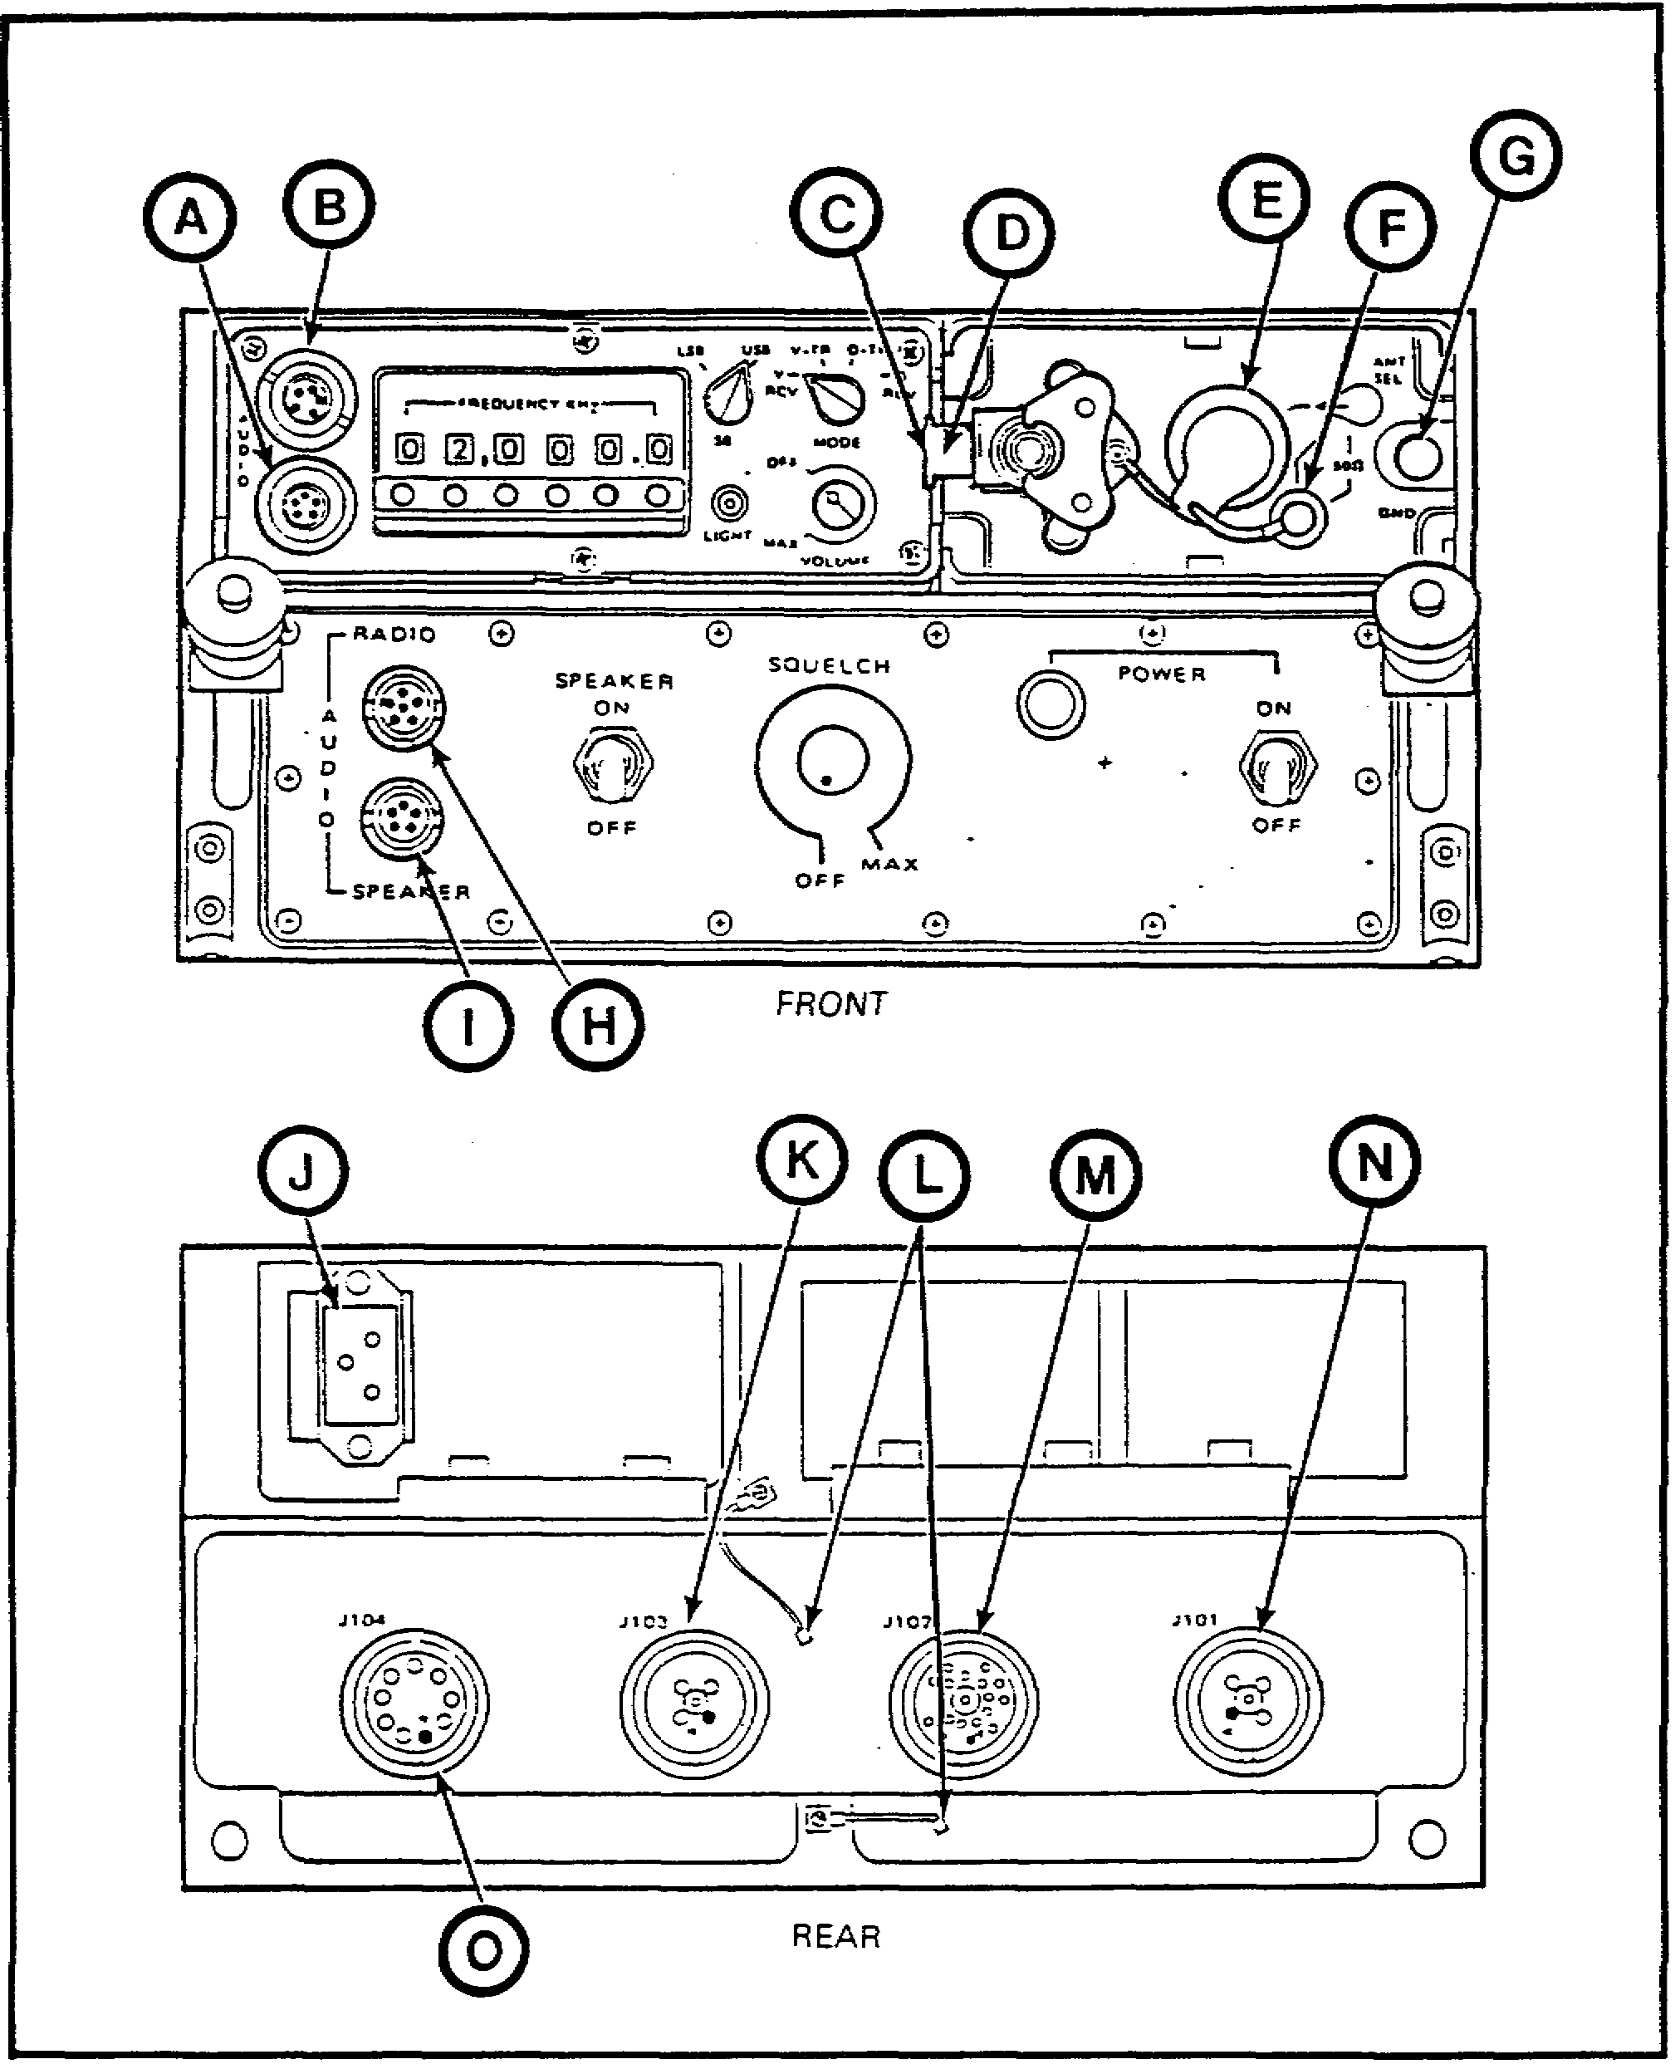

Figure 12. AN/GRC-213 connectors.

39

Table 7. Connectors and functions.

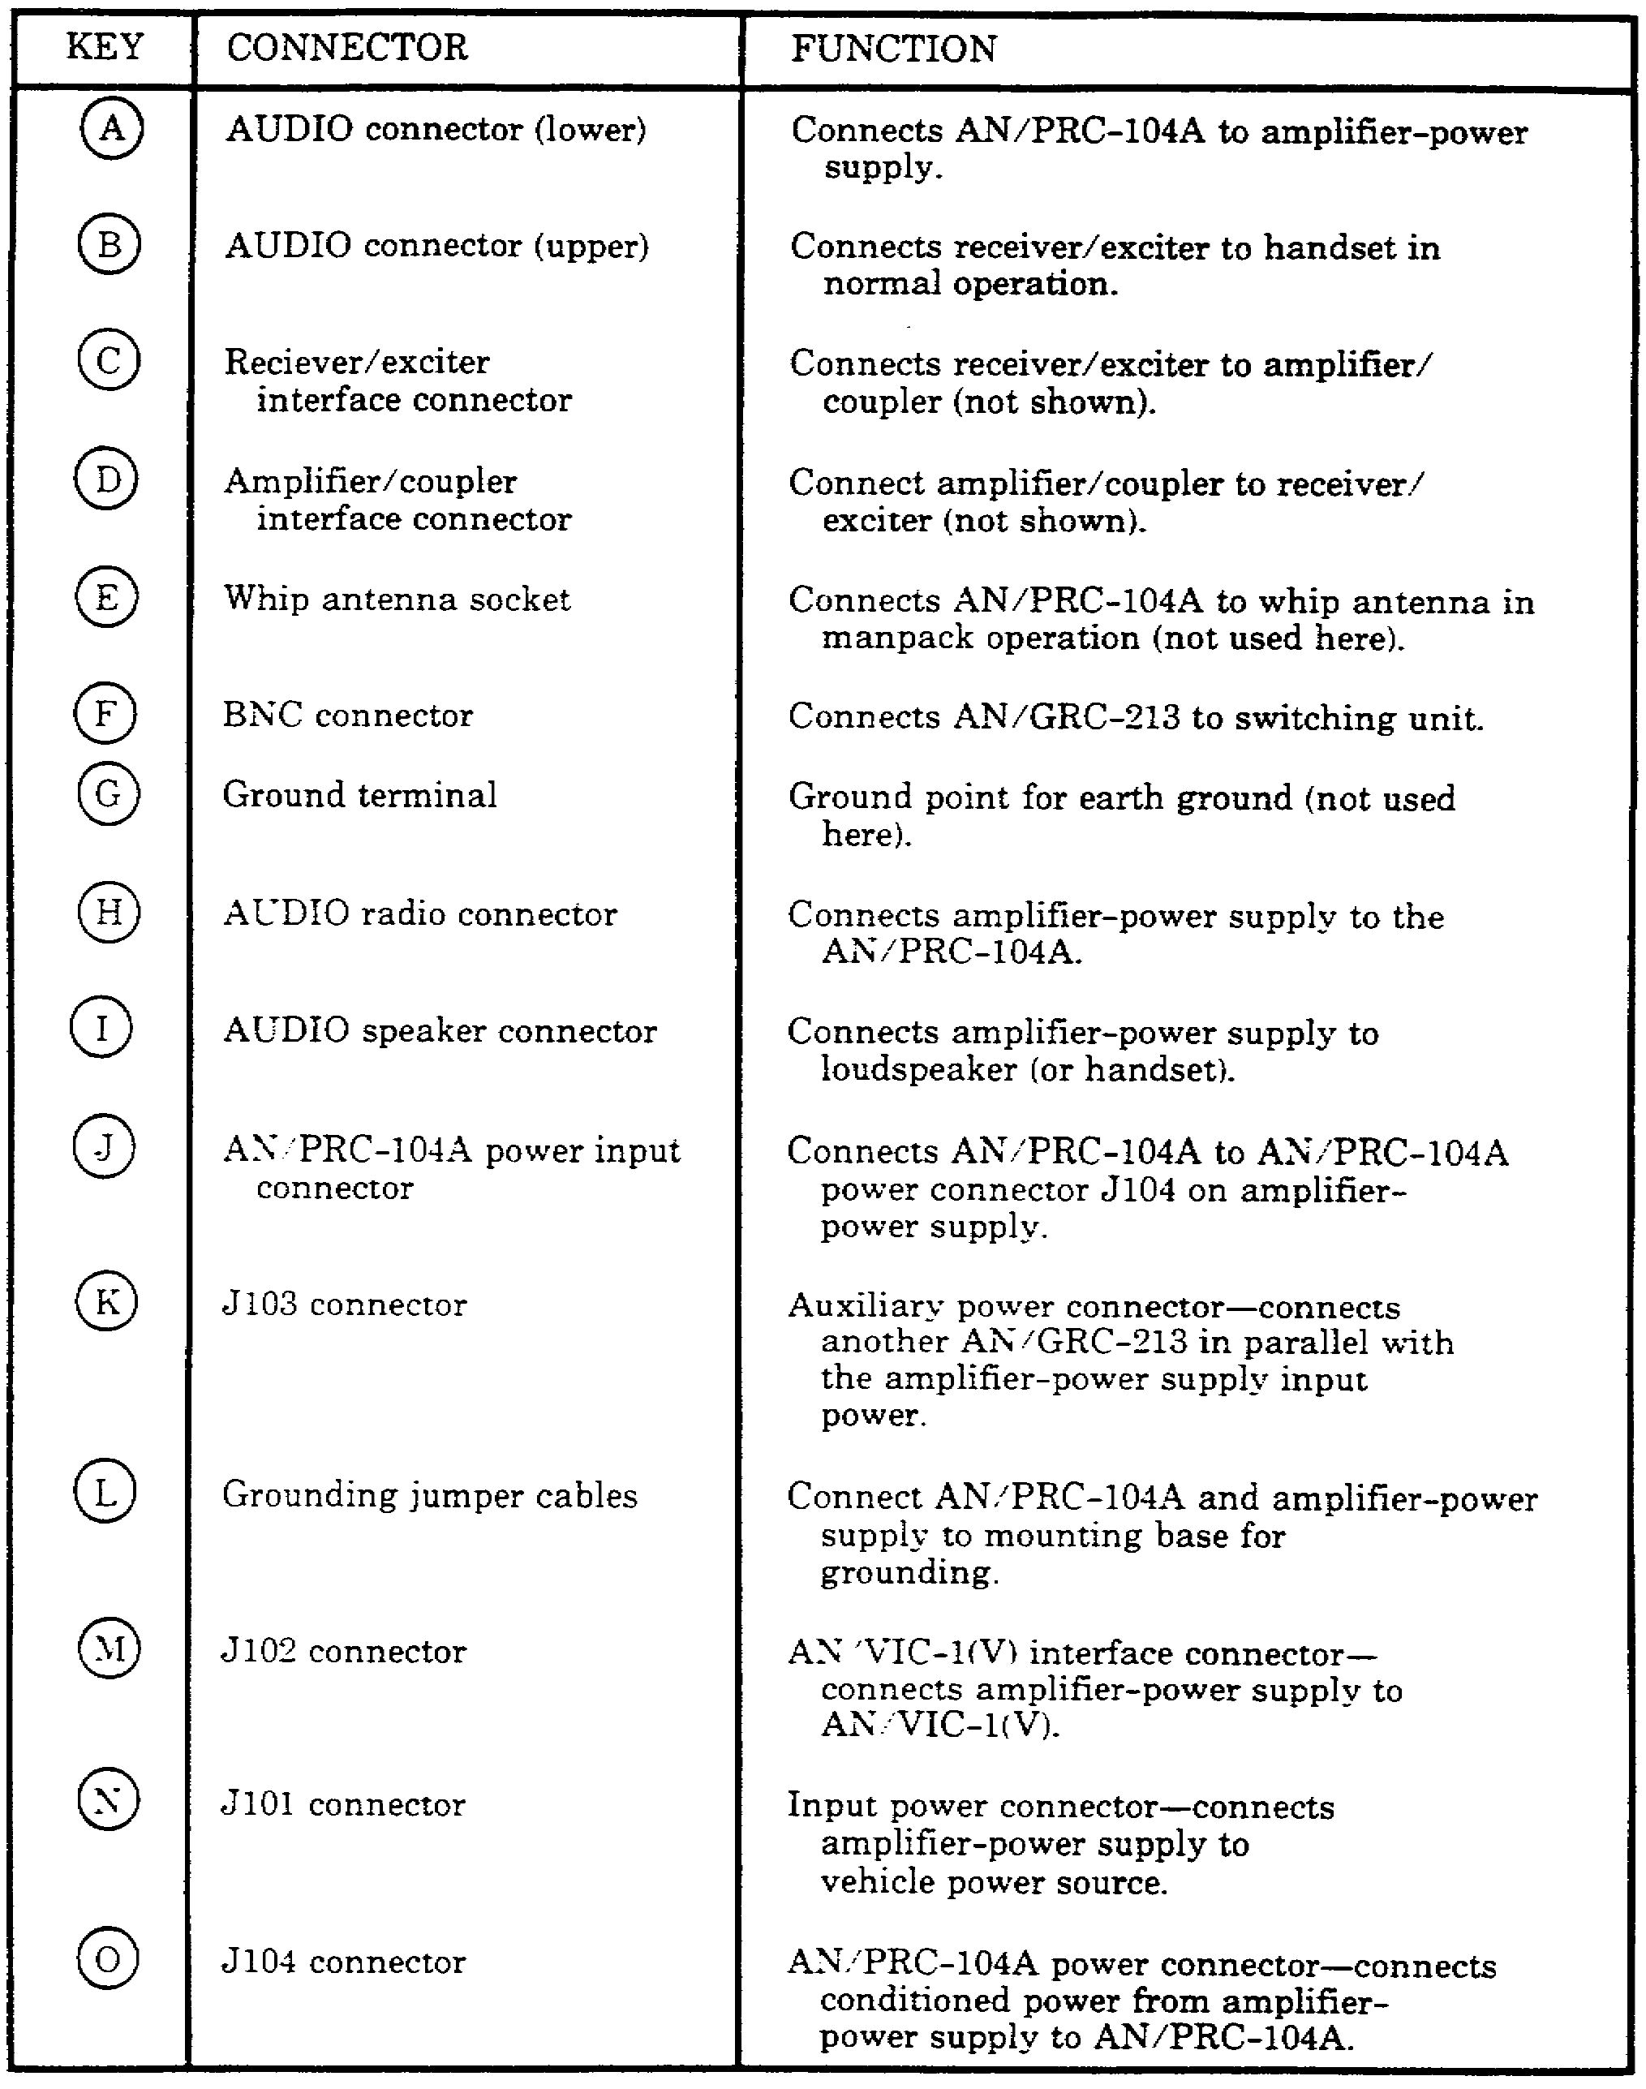

40

• Connect the audio cable that is attached to the front of AM-7152 by a short strap to the upper audio radio connector that is located on the front of the AM-7152. Connect the other end of this cable to the lower audio connector on the front of RT-1209. Ensure that you have the audio cable connected as it was described for you. If you have it connected to the lower connector (speaker) on the AM-7152, it will cause the radio to key continuously when power is applied to the radio set.

• Connect the RF cable from the BNC connector on the amplifier/coupler to the BNC radio-RF connector J201 on the antenna switching unit (part of the mount).

• If the loudspeaker is to be used in the radio, connect the LS-454 loudspeaker to the lower audio speaker connector on the front of the RT-1209.

• Connect an H-250 handset to the upper audio connector on the front of the RT-1209.

• If the dipole antenna is used in place of the whip antenna, you must connect the dipole RF cable to the dipole antenna adapter. Then you can connect the cable with the adapter attached to connector J203 on the rear of the antenna switching unit.

b. The AN/GRC-213 has to be grounded for safety and proper operation. Grounding straps with quick-release connectors are installed on the rear of the receiver/exciter and the amplifier-power supply. There are two grounding straps attached to the mounting tray. The mount is grounded to the vehicle chassis. You are required to connect the ground from the receiver/exciter and the amplifier-power supply to the two straps coming from the radio mount. The connection from the mount to the chassis ground already should be connected. However, you should not assume that it is. You should check it. If you are not sure where it is connected on the vehicle, check the mount installation instructions for the particular vehicle in which the radio set is installed. Refer to TM
11-2300-476-14-P for this.

26. SUMMARY. In this lesson, you have learned how to install the AN/GRC-213 onto a vehicular mount for operation as a stand-alone radio set. This lesson is very important, because before you can operate this radio set, it must be installed properly.

41

Lesson 6
OPERATE RADIO SET AN/GRC-213

OBJECTIVE

After completing this lesson, you will be able to operate radio set AN/GRC-213.

REFERENCES

This lesson is based on the contents of TM 11-5820-923-12 and other materials approved for US Army instruction. However, development and progress render the text continually subject to change. Therefore, base your examination answers on material presented in this lesson rather than on individual or unit experience.

27. INTRODUCTION. During this lesson, you will learn the presets that you as the operator of radio set AN/GRC-213 will be required to perform. You also will learn the procedures needed to successfully operate this radio set. This will include some of the operational considerations that you should look at when you are required to operate the radio in the field.

28. OPERATOR'S CONTROLS AND INDICATORS.

a. Before you can make any of the presets that are required, you need to know what the controls and indicators are and their functions. Table 8 lists for you the controls and indicators and what their functions are. Figure 13 will show you the location of these controls and indicators. The letters with arrows pointing to the control or indicator correspond to the reference key in Table 8.

b. There also are some audible indicators that you should already be familiar with. These were described for you in Lesson 2. To refresh your memory, the audible indicators that will be heard in your handset are as follows:

• Low power indication - clicking sound in the handset

• Power output indication - sidetone in the handset.

• Tuning indication - 1-kHz tone in the handset.

• No tune indication - a continuous beeping that is heard in the handset.

• VSWR mismatch indication - a short beep at beginning of transmission.

• Tune indication - 1-kHz tone for 3 to 12 seconds.

29. ENVIRONMENT. Another thing that must be considered before operating is your operational environment Section II of TM 11-5820-919-12 discusses the operational considerations. These considerations enable you to make your site selection, frequency selection (if this decision is left up to you), and so on. These will affect some of the presets that you have to make.

43

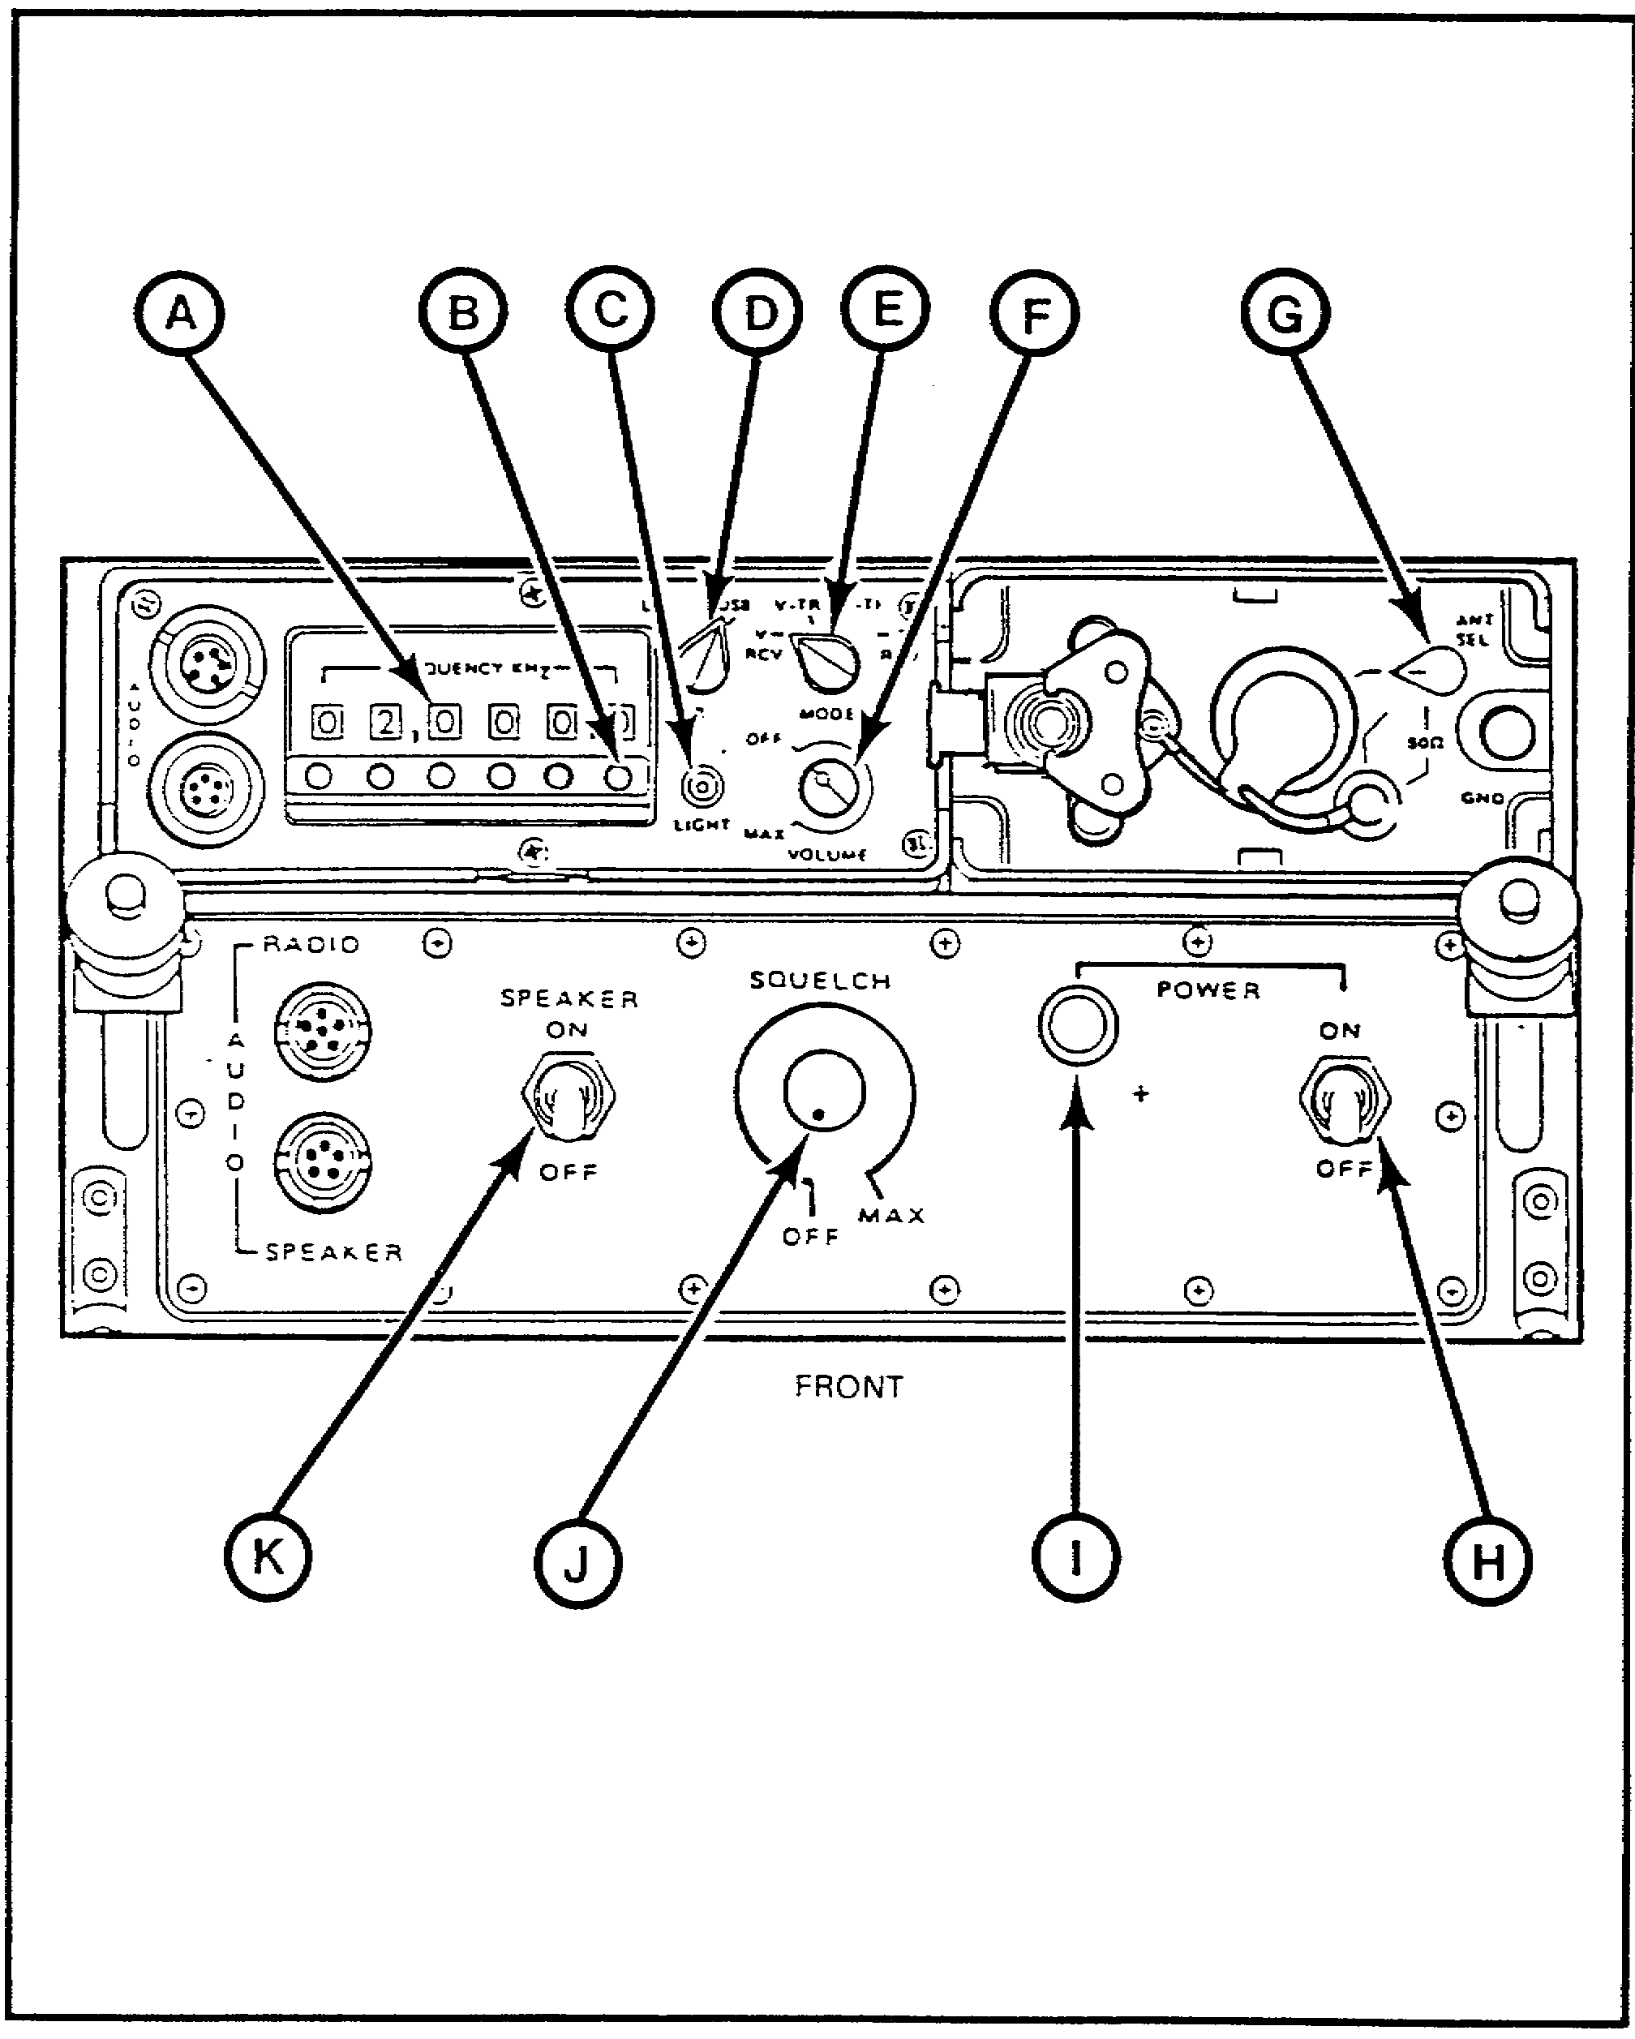

Figure 13. Controls and indicators of radio set AN/GRC-213.

44

Table 8. Controls and indicators.

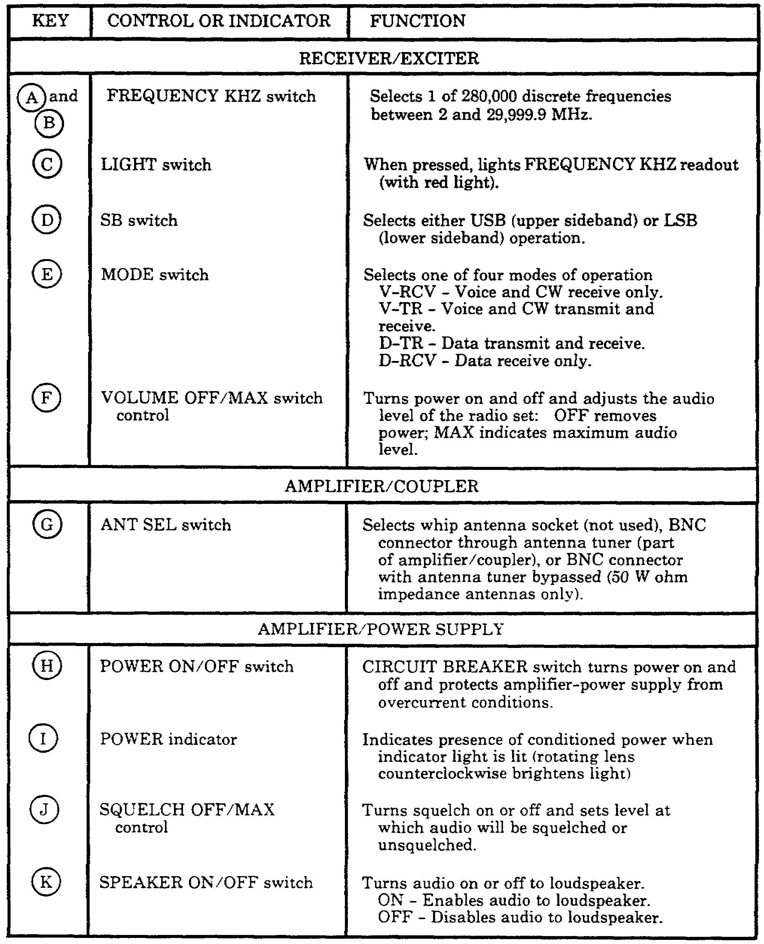

45

30. INITIAL PRESETS. Your initial presets for the radio set will be described in the following subparagraphs.

a. Check to make sure that you have made all cable connections that are required as described in Lesson 5.

b. Make the following settings on the amplifier/coupler and receiver/exciter:

• Set the MODE switch to V-TR.

• Set the ANT SEL switch to the middle BNC connector position.

• Set the SB switch to either USB or LSB, whichever is required.

• Set the FREQUENCY KHZ push buttons to the desired operating frequency.

c. Make the following settings on the amplifier-power supply (AM-7152):

• Set the SPEAKER ON/OFF switch to ON if the speaker is to be used. If just the handset is to be used or if nothing is attached to the lower AUDIO SPEAKER connector, then the switch should be in the OFF position.

• Turn the SQUELCH OFF/MAX control fully counterclockwise, and then adjust it clockwise until the squelch quiets the background noise. (The adjustment can't be done until power is applied.)

d. Set the ANTENNA LOADING switch to the appropriate position as dictated by the operating frequency and antenna selected for use as follows:

• Whip or NVIS antenna. For a frequency of 2 to 10 MHz, set the switch to the 2-10 position. For a frequency of 10 to 29.9999 MHz, set the switch to the 10 to 29,999.9 position.

• Slant wire or dipole antenna. For any frequency when using one of these two antennas, set the switch to the DIPOLE position.

31. POWER. When you have made all the preceding settings on the radio set, you are ready to apply power to the radio set. You should perform the following:

• Set the POWER ON/OFF switch on the amplifier-power supply to ON. The power indicator light should come on.

• Set the VOLUME OFF/MAX control on the receiver/exciter to a comfortable listening level.

32. OPERATION OF RADIO SET AN/GRC-213. Now that you have learned the initial presets and how to start up the radio, you are ready to operate it.

a. To operate the radio set for normal two-way voice communications, you should do the following:

46

• Check to ensure that a1l required cable connections and control settings have been made. If any of them have not been made, make them now.

• Press the PTT switch on the handset to start the radio tuning. You should hear the 1-kHz tuning tone in the handset. Release the PTT switch.

• When the radio set has tuned, press the PTT switch and hold it. Speak into the handset to transmit. A sidetone (your voice) should be heard in the handset. Release the PTT switch to hear the distant station reply.

• Adjust the SQUELCH control so that distant stations still can be heard when they are trying to talk and to eliminate the background noise.

b. If the tactical situation requires you to operate under listening silence, you should set the MODE switch on the receiver/exciter to the V-RCV position. This disables the transmit portion of the radio and prevents accidental transmitting of your radio set.

c. To shut the radio set down at the conclusion of the operating requirement, set the POWER ON/OFF switch on the AM-7152 to the OFF position and the VOLUME OFF/MAX control on the receiver/exciter to the OFF position.

PRACTICE EXERCISES:

10. The MODE switch on the RT-1209 is used to select one of four modes of operation, these four modes of operation are __________, _________, __________ and __________.

11. The SB switch on the RT-1209 is used to select either __________ or __________.

12. The FREQUENCY KHZ switches can be used to select a frequency from __________ to __________.

13. The switch used to select the type of antenna being used with the radio set AN/GRC-213 is located on the __________ __________.

/ / / / / / / / / / / / / / / / / / / / / / / / / / / / / / / / / / / / / / / / / / / / / / / / / / / / / / / / / / / / / / / / / / / / / / / / / / / / / / / / / / / / / / /

ANSWERS:

10. V-RCV, V-TR, D-TR, D-RCV.
11. USB or LSB.
12. 2.000.0 to 29.999.9.
13. AM-6874/PRC-104 amplifier/coupler.

/ / / / / / / / / / / / / / / / / / / / / / / / / / / / / / / / / / / / / / / / / / / / / / / / / / / / / / / / / / / / / / / / / / / / / / / / / / / / / / / / / / / / / / /

33. SUMMARY. During this lesson, you have learned how to prepare and operate radio set AN/GRC-213 for normal voice operation.

47

Lesson 7
PERFORM OPERATOR'S PREVENTIVE MAINTENANCE CHECKS
AND SERVICES ON AN/GRC-213

OBJECTIVE

After completing this lesson, you will be able to perform PMCS on radio set AN/GRC-213.

REFERENCES

This lesson is based on the contents of TM 11-5820-923-12 and other materials approved for US Army instruction. However, development and progress render the text continually subject to change. Therefore, base your examination answers on the material presented in this lesson rather than on individual or unit experience.

34. INTRODUCTION. The performance of maintenance and troubleshooting of this radio set is very important. It can mean the difference between being able to complete a mission and not being able to. As a result, you should place emphasis on performing the preventive maintenance and being able to troubleshoot the radio set if a fault should occur. In this lesson, you will learn what preventive maintenance you are required to perform and know what the troubleshooting procedures are for the radio set.

35. OPERATOR'S PREVENTIVE MAINTENANCE. Operator's preventive maintenance includes, but is not limited to, cleaning, corrosion control and performance testing. These checks and services are performed on a regular basis. The frequency with which PMCS should be done is listed in Table 9. Even though these tasks might seem unimportant and trivial, you should keep in mind that the reason you perform preventive maintenance is to keep the radio set operational. Lack of proper preventive maintenance is the cause of equipment failure more often than not. Preventive maintenance should be performed as follows:

a. Cleaning. You should remove dirt dust, grease, or any debris from the external surfaces by using a cloth or brush moistened in clear water. Rinse the equipment by using a clean cloth moistened in clean, clear water. Dry it off with a soft, lint-free cloth. Clean any dust and dirt from the connectors and pins by using a soft-bristled brush.

b. Corrosion control. You should check the radio set for any signs of corrosion or fungus. This should be done when you are operating or preparing for a mission. Corrosion and fungus can damage or destroy equipment in a short amount of time. When the equipment is not being used, you should separate the components and check the connectors, latches, and cables for any signs of this. When you are operating, you can check what is visible. If there are any signs of corrosion or fungus, they should be removed with a cloth or a brush moistened with a cleaning solvent, usually trichlorotrifluoroethane. Cleaning solvents should be used in a well-ventilated area. They can be damaging to your health if not used properly. When you have cleaned the corrosion or fungus off, you should repaint any areas that are supposed to be painted. This will help to prevent it from reappearing.

49

36. OPERATOR'S TROUBLESHOOTING. As the operator, your troubleshooting of the radio set is limited to fault isolation to a replaceable unit or accessory. You will use the operational indicators and audible tones in the handset that you have already learned to help you isolate faults. See Table 10 for a performance test. If a component is not performing as is indicated in the performance test, a higher level of maintenance is required. You should use this performance test as a troubleshooting guide.

Table 9. Operator's daily and weekly PMCS.

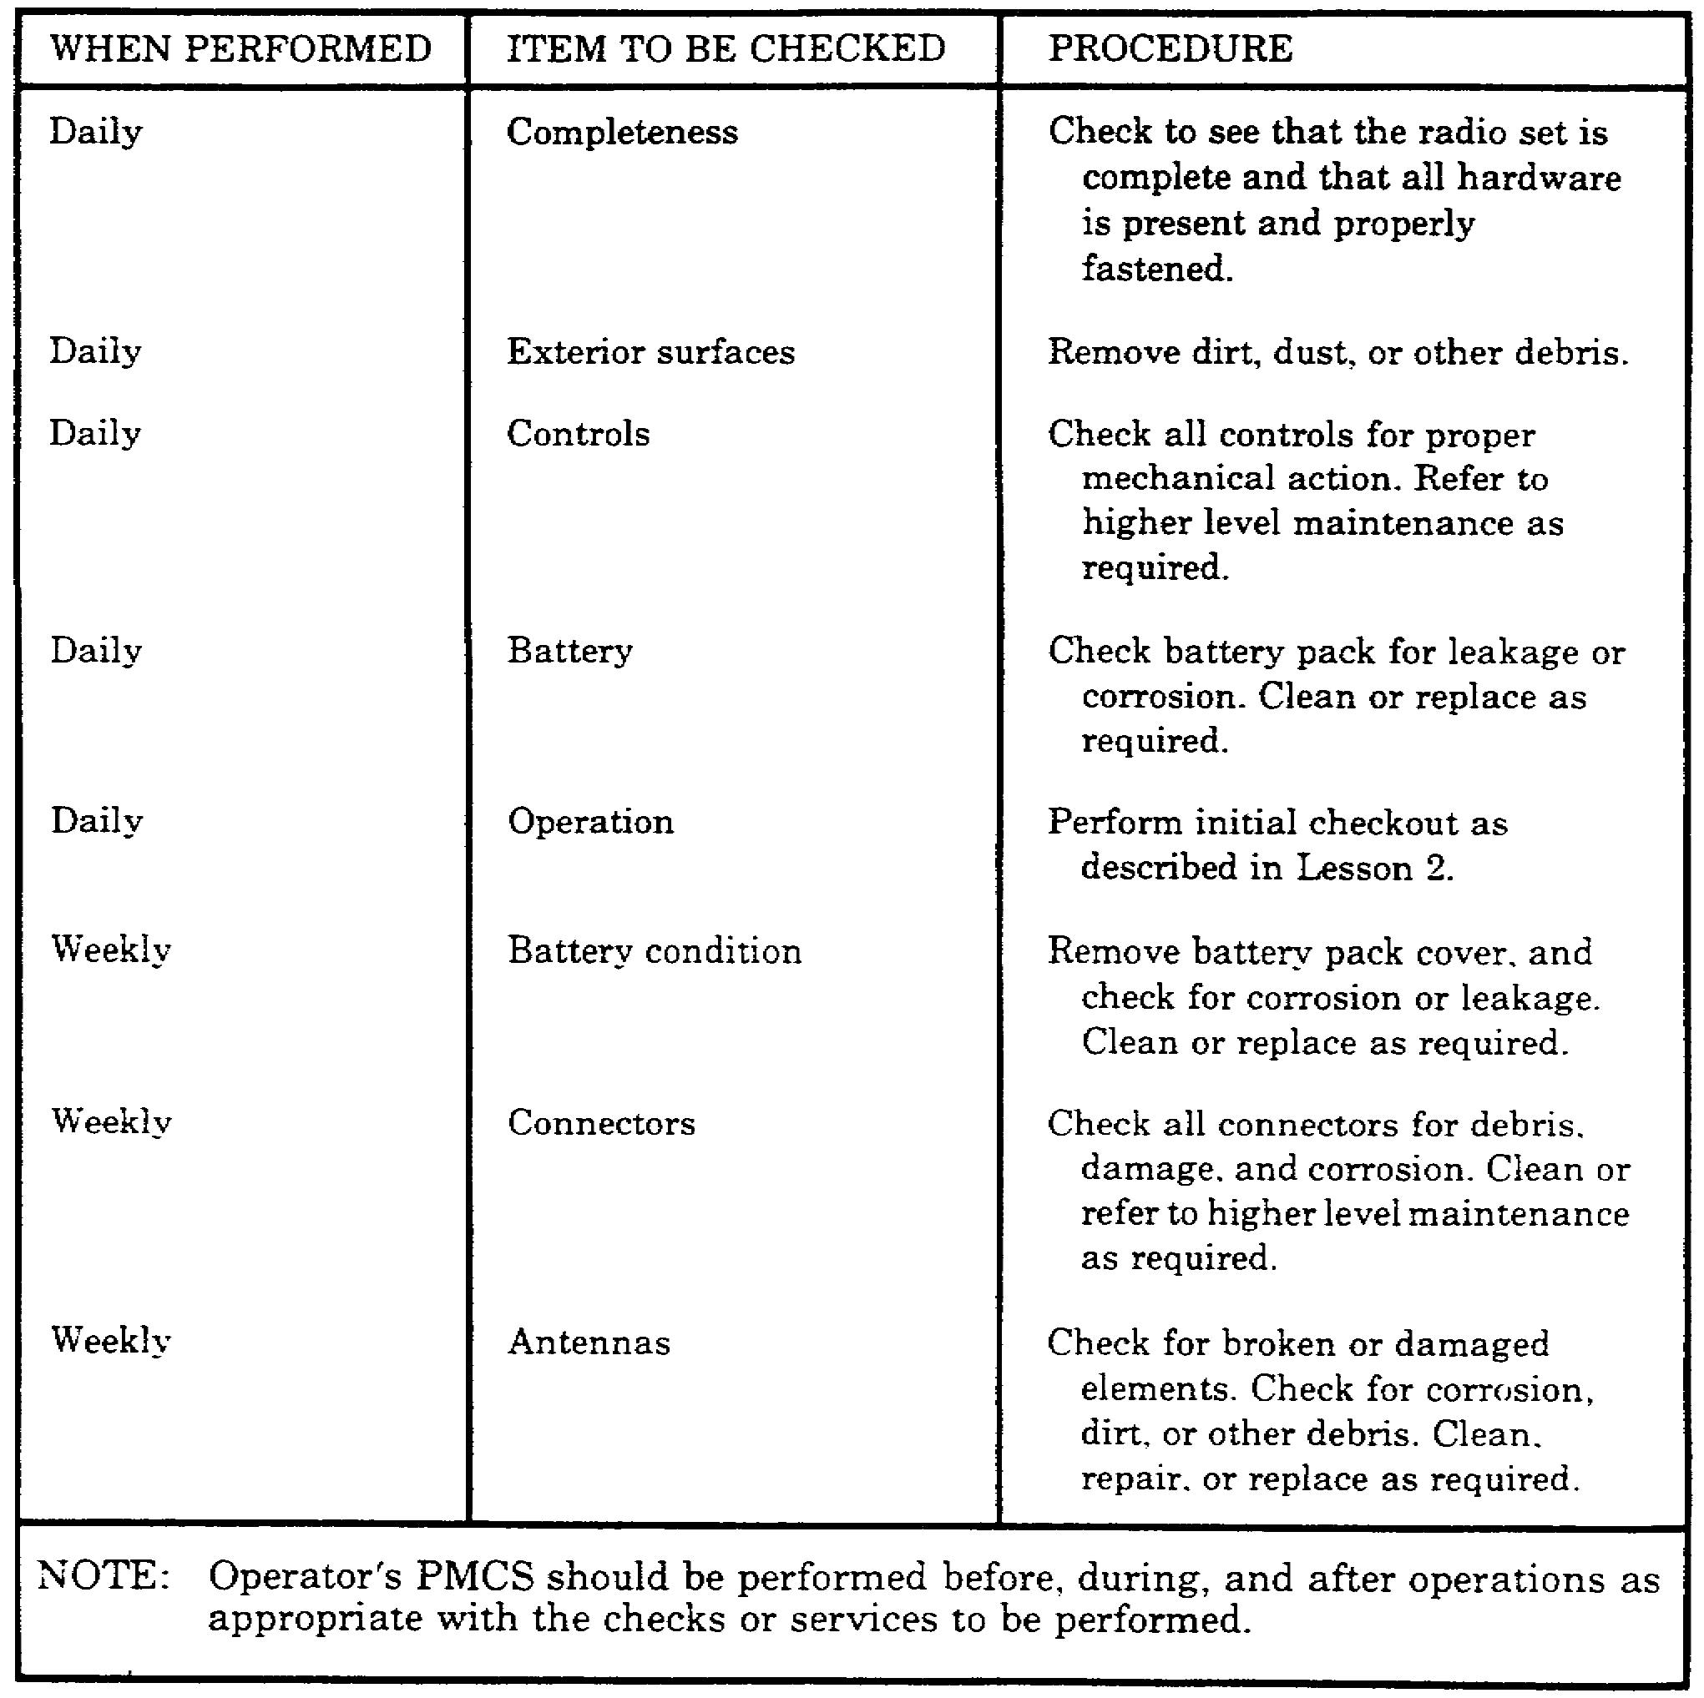

50

Table 10. EPC.

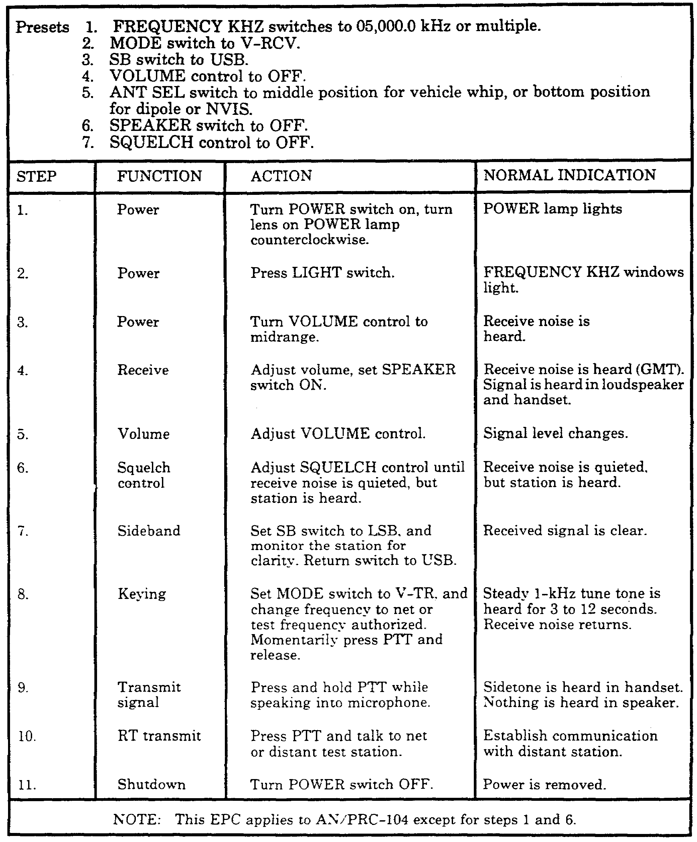

51

PRACTICE EXERCISES:

14. When should preventive maintenance be performed on radio set AN/GRC-213?

a. daily and weekly
b. daily and monthly
c. weekly and monthly
d. monthly and quarterly

15. You should clean exterior surfaces of the radio set __________.

a. daily.
b. weekly.
c. monthly.
d. quarterly.

16. Operator's preventive maintenance includes cleaning, __________, and performance testing.

a. troubleshooting
b. replacing switches
c. corrosion control
d. nothing else

17. The minimum performance test used as a troubleshooting guide for radio set AN/GRC-213 is found in what TM?

a. TM 11-5820-919-12
b. TM 11-5820-923-12
c. TM 11-5820-401-10
d. TM 38-750

18. Operator troubleshooting AN/GRC-213 is limited to--

a. fault isolation to a replaceable unit or accessory.
b. replacement of component modular boards.
c. replacement of the mount.
d. fault isolation to an internal circuit.

/ / / / / / / / / / / / / / / / / / / / / / / / / / / / / / / / / / / / / / / / / / / / / / / / / / / / / / / / / / / / / / / / / / / / / / / / / / / / / / / / / / / / / / /

ANSWERS:

14. a.
15. a.
16. c.
17. b.
18. a.

/ / / / / / / / / / / / / / / / / / / / / / / / / / / / / / / / / / / / / / / / / / / / / / / / / / / / / / / / / / / / / / / / / / / / / / / / / / / / / / / / / / / / / / /

37. SUMMARY. In this lesson, you have learned what preventive maintenance you as an operator are required to perform and how to perform it. You also learned to refer to TM 11-5820-923-12 for troubleshooting this radio set.
52

